Robot Project: CardIn Card Dealer

Department of Mechanical and Mechatronics Engineering

A Report Prepared For:
The University of Waterloo

Prepared By:
Group 21
Ruby Gao 21176960,
Ho Yan Lam 21181647,
Eric Zhang 21200470,
Tian Ma 21184715
200 University Ave.
December 2, 2025

Table of Contents
List of Figures iii
List of Tables iv
Acknowledgements v
Summary vi
1.0 Introduction 1
2.0 Scope 1
2.1 Main Functionality 1
2.2 Robot Interactions 1
2.3 Tasks Completion Recognition 2
2.4 Changes in Scope 2
3.0 Constraints and Criteria 2
4.0 Mechanical Design and Implementation 3
4.1 Prototyping 3
4.1.1 Gear Ratio 3
4.1.2 Bumper Collisions 3
4.1.3 Card Ejection 4
4.2 Chassis and Drivetrain Assembly 7
4.2.1 Overview 7
4.2.3 Version 2: Prototype Test Bed for Development (Early Nov) 10
4.2.4 Version 3: Final Product 11
4.3 Card Ejection Assembly 11
5.0 Software Design and Implementation 17
5.1 Prototyping 17
5.1.1 Colour Sensor Hues 17
5.1.2 Distance Sensor Testing 17
5.2 Overall Software Design 17
5.2.1 Software Summary 17
5.2.2 Modifications 18
5.2.3 Main Functions 19
5.2.4 Data Storage 22
5.3 Movement Class 22
5.4 Card Ejector 31
6.0 Verification 32
7.0 Project Plan 33
7.1 Task Division 33
7.2 Revisions to Project Plan 33
8.0 Conclusions 34
9.0 Recommendations 35
9.1 Mechanical Recommendations 35
9.2 Software Recommendations 35
References 35
Appendices 36

List of Tables
Table 1: Results of varying roller height and card holder angle 5
Table 2: Table of colour hues 16
Table 3: Overview of the Movement class 23

List of Figures
Figure 1: Bumper with tension assist. 3
Figure 2: Testing the effectiveness of a roller wheel spinning on an offset axis. 4
Figure 3: Labeled top view of CardIn V1 Robot 7
Figure 4: Labelled side view of CardIn V1 robot 7
Figure 5: Visual representation of CardIn V1 testing 8
Figure 6: Top view of CardIn V2 9
Figure 7: Side view of CardIn V2 9
Figure 8: Visual diagram of linear and rotational tests for CardIn V2 9
Figure 9: Bottom view of CardIn V3 10
Figure 10: Physical card holder 11
Figure 11: Early concept drawing of a potential way to eject one card at a time (note the angled ramp) 11
Figure 12: Final version of the 3D printed plates 12
Figure 13: 3 prototypes of front plates. First prototype (top), second (right), final (left). 12
Figure 14: Final weight design. 13
Figure 15: Weight placed on the center of the wheel and the front of where the cards would be placed with a skewer connecting it to the side plates 14
Figure 16: 3D printed ramp with attachment plates for securing to the robot (note the modifications made to the ramp on top) 15
Figure 17: Ramps attached to the robot 15
Figure 18: Flowchart for the setup stage 18
Figure 19: Flowchart for recording player locations 19
Figure 20: Flowchart for ending procedure 20
Figure 21: Flowchart for location-based distribution 21
Figure 22: Flowchart for spinning-based distribution 22
Figure 23: Equation and visual representation of smooth() function 25
Figure 24: Visual representation of findTangent() function 25
Figure 25: Graph representing the equation found in the smooth() function 26
Figure 26: Flowchart for spinToDegree() function 27
Figure 27: Flowchart for locationUpdate() function 28
Figure 28: Flowchart for moveTo() function 29
Figure 29: Phases of moveTo() function 30
Figure 30: Gantt chart for project 32

Acknowledgements
Outside of group 21, many people contributed to the success of this robot. Thank you to Ryan Consell, Divya, and an unnamed Software Engineering student for help in the debugging process. Thank you to Ryan T for advice on building a VEX odometry and Wikipedia for help with shuffling algorithms. Finally, a special shout out to Nick Vardin, of whom the robot is named after.

Summary
This project aimed to design and build a card dealing robot using VEX IQ pieces and custom 3D-printed parts. The idea was born out of the group members’ passion for card games and the desire for a quality-of-life upgrade to game nights. Given the limited timespan allocated for this project, the team limited the scope of this project to just a card dealer without additional features such as shuffling, rigging cards, etc. The robot was designed to be fast, compact, fair, and user-friendly. Prototyping was done as a group, then individual tasks were assigned once a clear idea of the robot was decided. The drivetrain is comprised of two powered wheels and one omni wheel set perpendicular to the others. The card ejection system is comprised of a roller, a card holder, a front plate, and weights. Even after the prototyping stage, the robot went through various design changes to better adhere to the groups chosen criteria. Two dealing methods were developed. One distributed cards in a circle, while the other drove to set coordinates to deal cards directly to each player. User inputs were given through the controller, VEX IQ brain buttons, and touch sensor while the robot sensed its environment through motor encoders, a bumper, and a colour sensor. While the final robot design could not meet all the requirements and constraints, it succeeded in all major processes. With more time, the robot’s design could be made more compact by swapping VEX IQ parts with 3D-printed components. The software could also be made more user friendly and easy to read.

Introduction
Whether it is Uno or poker, card games are a staple at social gatherings. As enjoyable as the games are, this group recognized the tediousness that comes with dealing after each round. This project addressed the issue through a card-dealing robot built using the VEX IQ system. An automated card dealer would be an impartial dealer with no conflicts of interest, thereby surpassing a human in minimizing error and remaining fair. Additionally, a robot can be programmed to deliver cards directly to each player, saving players the hassle of getting up to reach for their cards. By leveraging the mechanical components of VEX IQ and a programmed odometry for positional tracking, the team created a system that can quickly and accurately deal a chosen number of cards to a specified number of players. Ultimately, this robot demonstrated a hands-free, reliable, and repeatable solution to tedious card distribution and sets a precedent for future projects of this scope.

2.0 Scope

2.1 Main Functionality
The objective of this project was to design and build a card-dealing robot capable of distributing playing cards evenly to multiple players. In its final version, the robot selects a player, moves to the designated position, and delivers a predefined number of cards using a mechanical ejection mechanism. Throughout development, several design constraints were identified. Surface conditions, lighting, and the maximum number of players all influenced the system configuration. The final design accommodated up to seven players to maintain reliable odometry performance and consistent card delivery.
The primary tasks performed by the robot include:
- Selecting a player based on programmed control logic
- Navigating to the appropriate location using odometry feedback
- Dispensing cards through a controlled ejection system

2.2 Robot Interactions
The robot used motor encoders and the VEX IQ Brain inertial sensor to support automated motion control. These sensors enabled the system to estimate its position via odometry and navigate to preset locations (For details about the odometry and drive system, see section 5.3). It also used the bumper to detect collisions and the colour sensor to detect if cards remain. In addition to sensor feedback, the robot received input from buttons on the VEX IQ Controller and Brain, which were used in the set up and shut down procedures. Operational parameters, such as the number of players and the number of cards to dispense per player, were programmed directly into the system and stored as internal variables. These values form the basis of the distribution sequence and ensure consistency during operation. The robot also monitored internal tracking variables, including the current player index and remaining card count, to determine when to proceed, cycle to the next player, or conclude the process. Having taken all this information into account, the robot powered its two drive motors to travel. Once the desired position was reached, it spun the roller motor to distribute the card.

2.3 Tasks Completion Recognition
The robot determined task completion through programmed logic that tracked the current player index and total number of cards dispensed. Once the robot has completed distribution for all players, the system would recognize that the task cycle was complete and end the dealing sequence. This relied on internal variable tracking that was based on preset operational parameters. The shutdown procedure was initiated through a button press on the controller or the brain interface (For more details, read section 5.2). Upon shutdown, the robot would stop all motor activity and reset program variables where applicable. This ensures that the system remained in a safe and inactive state until it is restarted for the next cycle.

2.4 Changes in Scope
During the early stages of development, the project included additional functionalities such as card sorting and deck rigging logic. Due to time constraints and inconsistency with the colour sensor, these features were removed. Instead, the project scope shifted to focus solely on accurate card distribution and movement using odometry and the ejection mechanism. Additionally, more options were incorporated into the shutdown procedure to allow greater flexibility for the operator, including multiple end-program conditions such as completing the distribution cycle or manually stopping the robot via controller input. These adjustments ensured that the design remained functional, feasible, and aligned with core project objectives.

3.0 Constraints and Criteria
Requirements and constraints were derived by aspects the group would personally desire in a card dealing robot of their own. Given the nature of the robot, they wished for the dealer to be fast, easy to carry, easy to use, and fair, making it optimal for the user. These factors drove a majority of the group’s decision-making process. In the end, fast dealing was ultimately not considered that much, as it would be easily impacted by mechanical and software factors outside of our ability to fix, such as encoder accuracy, wheel slip, and dealing-drivetrain integration. Compactness was a driving factor in mechanical design, as the drivetrain itself was made and revised constantly to become as small as possible, especially influencing the small wheelbase and 3-wheel design.

4.0 Mechanical Design and Implementation

4.1 Prototyping

4.1.1 Gear Ratio
Given that speed was a desired feature on the robot, the group ran some tests to determine the fastest the roller wheel could spin. A gear train consisting of six gears, arranged as three pairs of a 24‑tooth gear meshed with a 48‑tooth gear, was initially created to convert as much torque as possible into speed, however, it was quickly discovered that the motor did not have the necessary power. The motor began spinning and the gear train did not move. One pair of gears was removed from the gear train, and while the motor was able to drive the system, it shook from the effort. With only two gears, the motor was able to run smoothly with only small vibrations. There was a noticeable increase in speed compared to driving the roller directly with the motor. Nevertheless, after some discussion, the team decided to scrap the use of a gear train entirely. While speed was important, if the distribution system was too fast, it would be more inaccurate to control with encoders. The gear train would also cause the robot to become bulkier, and the team decided that minimal speed increase was not worth the additional weight.

4.1.2 Bumper Collisions
Although the initial plans for the robot did not include the bumper, it was later added to prevent collisions from impacting the trajectory of the robot. For this to work, the plate attached to the bumper needs to be the same width as the robot itself. However, it was discovered that with a longer plate, it became more difficult for the bumper to detect collisions that happened to the edge of the plate it was attached to. The solution, shown in Figure 1, was a complex entanglement of string designed to use tension to evenly spread out the force to the entire plate.
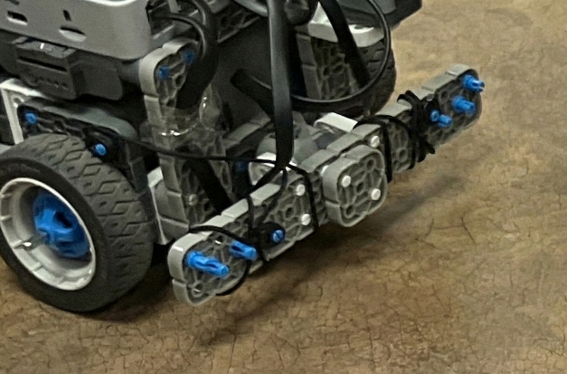
Figure 1: Bumper with tension assist.

4.1.3 Card Ejection Roller
Off-centered spinning axis
The biggest problem concerning the card ejector was how to distribute one card at a time. Spinning a roller wheel on its own is not enough. When one card is about to be ejected, the roller will inevitably contact the next card above it and move it as well. This movement builds up over time and causes multiple cards to be ejected at the same time. The first prototyped idea was that of a roller spinning on an off-centered axis. Seen in Figure 2, the logic was that the roller would have a period of time where it did not contact the cards and thus, only distribute one card at a time. It appeared to have better results than a non-offset roller.
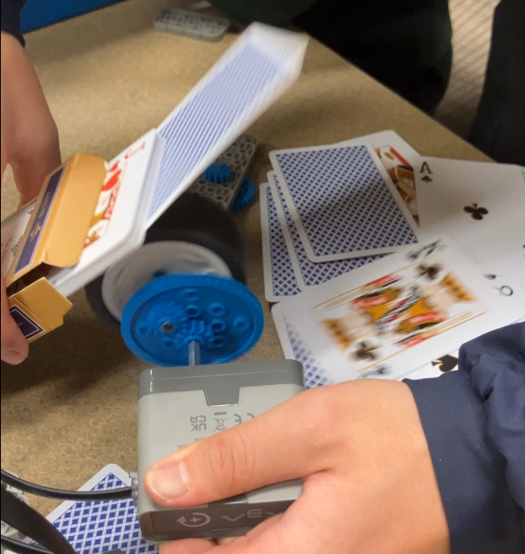
Figure 2: Testing the effectiveness of a roller wheel spinning on an offset axis.
Different angle positions and wheel placements
The team then experimented with different wheel placements and card holder angles using a temporary card holder built of VEX IQ parts. The results are in Table 1. While the behaviour of the robot improved, it was still not satisfactory for the group. To investigate other avenues of improvement, the team ran trials holding the cards up with their hands to the wheel at different angles to simulate different possible card holders that were not possible with the fixed positions of vex parts. They came to the realization that the pressure pinching the sides of the cards was also a significant factor. This was the main contributing factor that led to the card holder getting 3D-printed, as it required a specific width for the card holder that was not possible to achieve with the vex pieces. (For more information regarding the card holder, see section 4.3)
Table 1: Results of varying roller height and card holder angle
Testing roller height and card holder angle | Results
Card holder angle up to top hole and roller at outer ring | Very inconsistent. Spits out multiple cards sometimes and no cards other times
Roller moved down | Cards don't reach roller :(
Lowered card holder angle | First couple cards looked good, however it became inconsistent as the number of cards left decreased
Taped roller
Another idea tested by the group was taping sections of the roller wheel to reduce friction. The reasoning was the same as that of the off-centered roller—to decrease the contact the wheel has with the cards. When testing this idea, the group discovered that it was difficult to make the scotch tape sit flush against the surface of the roller. The tape also began to unravel as the roller began to spin. Due to the poor results and additional effort this method would take, the group decided against the idea.
Egg-shaped roller
While the egg-shaped roller was never tested, the idea was heavily discussed as a possibility. The design was inspired by camshaft lobes, which have unique shapes to contact valves at precise timings. It would be smaller than the offset wheel design but would still require a larger clearance underneath the robot so that the roller does not contact the ground while spinning.
Spin roller forward then back
By spinning the roller back after each ejection, it resets the next card that might have unintentionally shifted forward, back to the starting position. The movement forwards was controlled by the length that the roller’s perimeter should travel, whereas the movement back was controlled by the duration of time at which the roller would spin backwards. (For information about the software behind the card ejection system, look at section 5.4) The group tested for the optimal distance to spin forward and back in increments of 3 millimeters and 25 milliseconds respectively. The robot was tested by making it distribute the entire deck to four players and visually confirming that cards were dealt one at a time. The final values that yielded the best results were 104 millimeters and 225 milliseconds. This method of distribution worked even when powering the roller directly. As it was simplest mechanically, the group settled for this method of ejection.

4.2 Chassis and Drivetrain Assembly

4.2.1 Overview
The chassis and drivetrain of the robot were developed together to achieve 4 specific goals:
- The chassis must be able to carry the card ejector subsystem without any interference issues.
- The drivetrain should provide consistent movement that can be tracked using motor encoders.
- The overall design must be structurally rigid enough to be carried and driven around without breaking, but also easy to disassemble and modify as needed.
- The overall design must be as small as possible while still achieving the previous goals.
With those 4 goals in mind, the development of the chassis and drivetrain began a day after initial testing of the card ejector was conducted.

4.2.2 Version 1: Initial Prototype and Viability Tests (Oct 11-12)
This initial prototype was a test for several design choices. The primary design choices tested were the height of the axles (shown in Figure 4) as well as the spacing, location, type, and number of wheels. As shown in Figure 3, the design utilized a unique setup of offset drive wheels, as well as a 3-wheel setup composed of 2 drive wheels on the sides and a free spinning rear wheel. This design attempted to maximise space for the ejector while minimising the width of the robot. The tires selected were 1 rubber and 2 omnis which alleviated any issues arising from offset drive wheels while turning.
The prototype was tested with basic linear drive functions, and results from the test can be seen in Figure 5, where the prototype would consistently veer off to one side. Analysis of the robot during motion under load and without load led to a hypothesis that either the offset design of the wheels led to the veering, or that the non-perfect shape of the rear omni-wheel resulted in the robot deflecting to the side.
Further tests with rotating on the spot were conducted with results shown in Figure 5. Although rotation occurred without a loss of traction in the rubber drive wheel, the omni-wheel attached to the other motor resulted in an offset center of rotation depicted in Figure 5.
Gathering information from the two movement tests, the team concluded that an offset drivetrain design was impractical as it made goal 2 (in sec. 4.2.1) harder to implement, and the inaccuracies of linear drive were too great of a magnitude to implement software heading correction. It must be noted that the rest of the design was proven to be viable in achieving all other stated goals, so the wheel height and 3-wheeled drivetrain were kept for future designs.
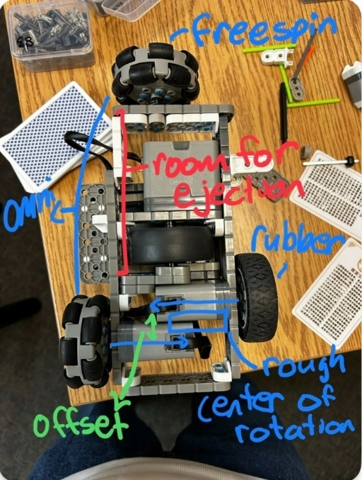
Figure 3: Labeled top view of CardIn V1 Robot
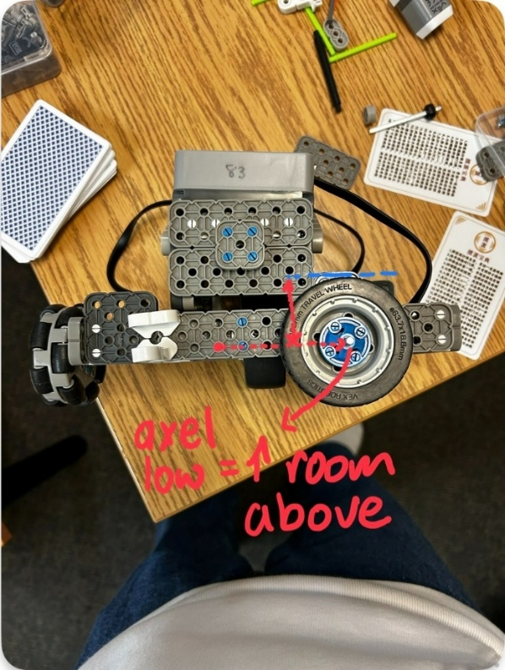
Figure 4: Labelled side view of CardIn V1 robot
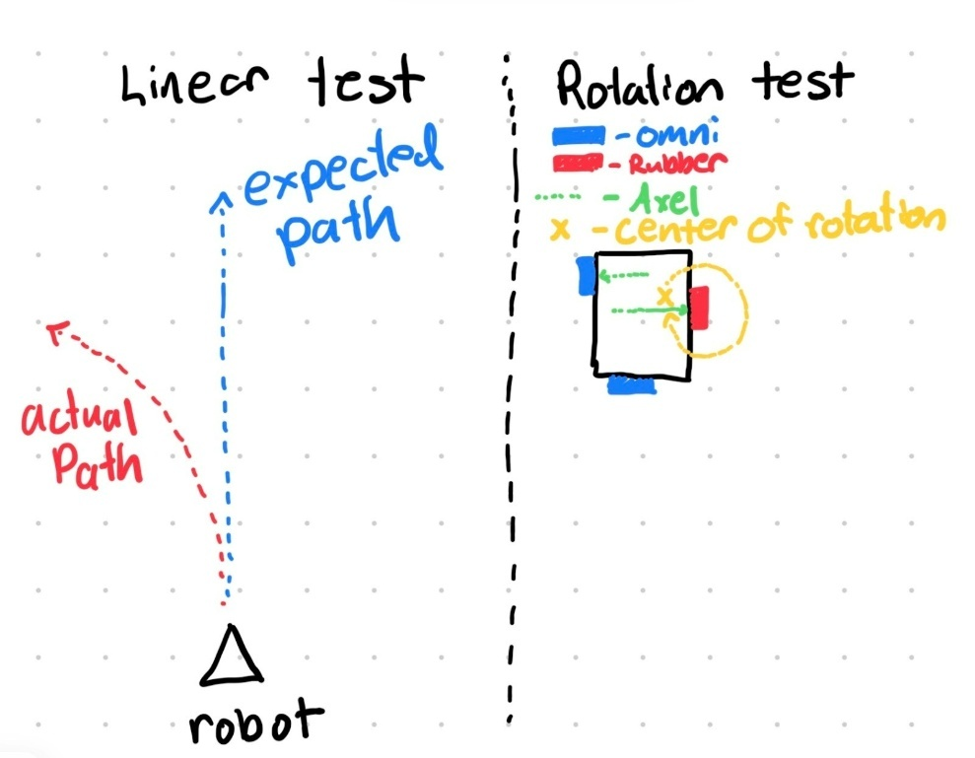
Figure 5: Visual representation of CardIn V1 testing

4.2.3 Version 2: Prototype Test Bed for Development (Early Nov)
The second prototype served as a testbed for all other subsystems and provided design updates from the first. Predominantly, the offset drivetrain was replaced with a collinear drivetrain shown in Figure 6, and both drive tires were rubber 200mm tires. This increased the width of the chassis, which became capable of supporting larger ejector designs seen in Figure 6. Further changes to the chassis and connectors created a more rigid product (see Figure 7) and provided stable mounts for the VEX IQ brain above the center of rotation.
Linear and rotational tests were conducted and the robot behaved predictably as shown in Figure 8. As a result, the general concepts of this design were kept in the final robot, with small variations in size.
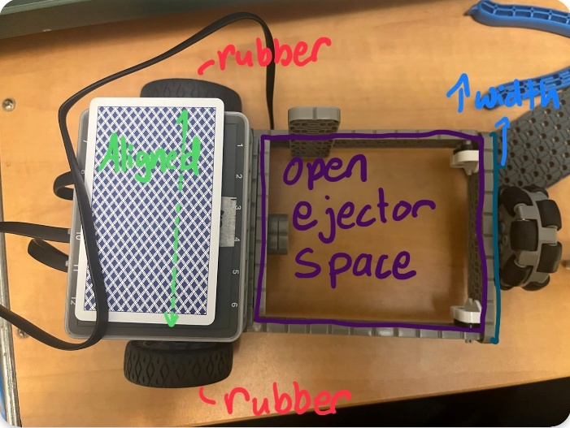
Figure 6: Top view of CardIn V2
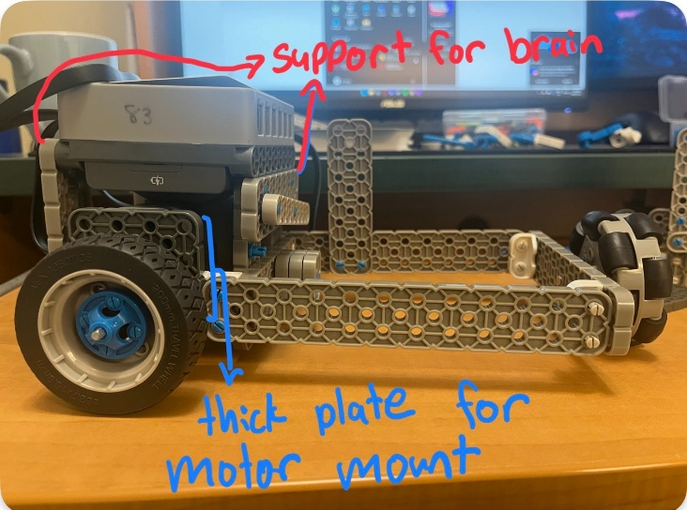
Figure 7: Side view of CardIn V2
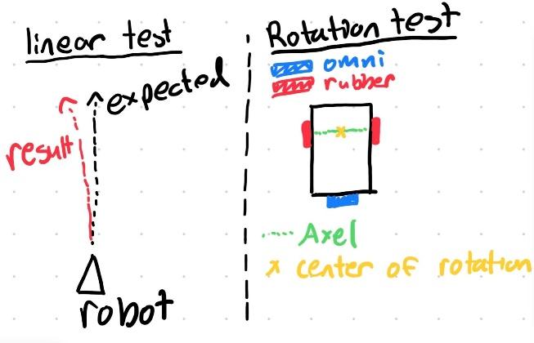
Figure 8: Visual diagram of linear and rotational tests for CardIn V2

4.2.4 Version 3: Final Product
The final product contained minor design changes from the previous version. One change was a significant reduction in the length of the wheelbase by mounting the ejector motor to the outside. Although this change had little effect on the total length of the robot, the smaller wheelbase reduced the chance of the robot running over previously dispensed cards. All major changes are depicted in Figure 9.
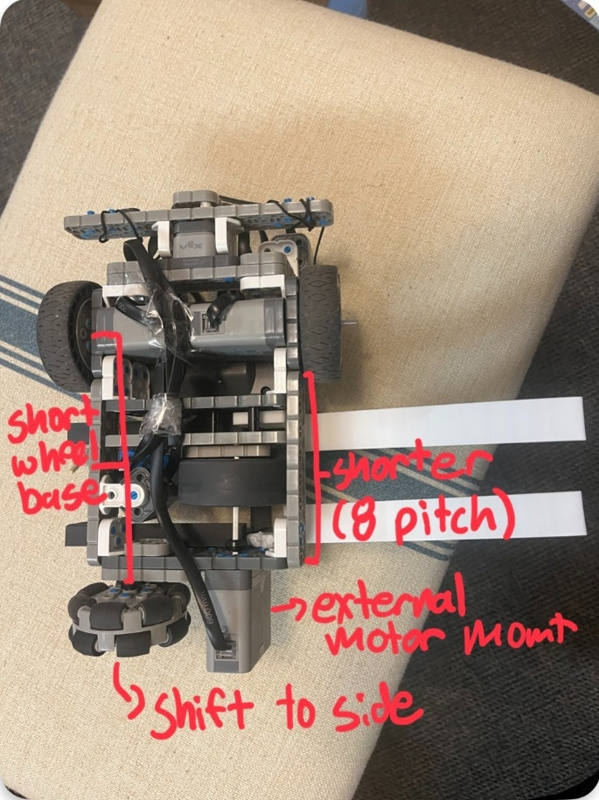
Figure 9: Bottom view of CardIn V3
4.3 Card Ejection Assembly
The card ejection assembly was comprised of multiple components that worked together to keep the cards in place and eject one at a time.

4.3.1 Card Holder
The physical card holder consisted of 3D‑printed parts that enclosed the cards on three sides, as shown in Figure 10. The distance between the left and right plates was 5.5 VEX IQ holes or 69.85 millimeters, which was the width of poker cards. The rails on the sides and the lips at the back stabilized the cards on the wheel when the robot was in operation, keeping them in place. The two rails running parallel along the inside of the side plates were angled so gravity naturally pulled the cards down. This angled ramp concept was carried over from a previous design, which relied solely on VEX IQ parts and encountered difficulties in balancing the ramp angle with the wheel position. An early concept drawing, shown in Figure 11, illustrates the angled holder idea with an alternative method for ensuring that only one card would be distributed.
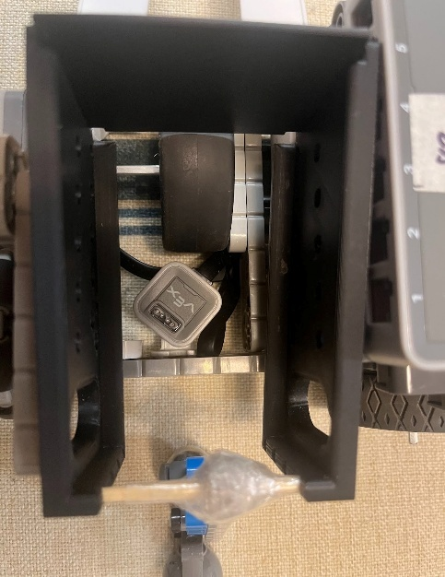
Figure 10: Physical card holder
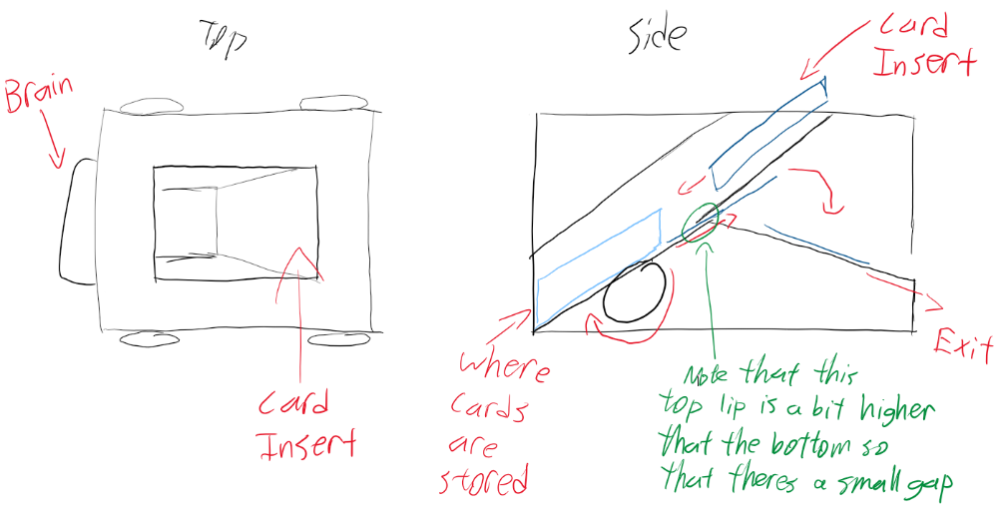
Figure 11: Early concept drawing of a potential way to eject one card at a time (note the angled ramp)
The side plates also incorporate custom holes to attach it to the robot using VEX IQ pins. The team added a slit at the front of the side plates to secure the front plate and position it at a height where the cards had to be ejected at a time (See Figure 12).

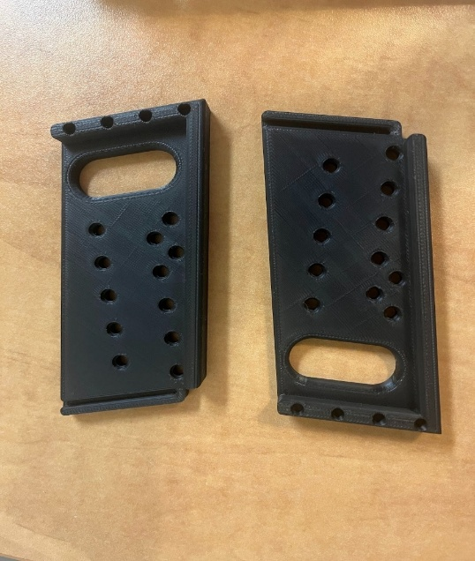
Figure 12: Final version of the 3D printed plates
The front plate concept was considered early in the design process but initially dismissed because it could not be fabricated using VEX IQ parts. At that stage, the team lacked experience with 3D printing and was uncertain about its capabilities or the complexity of the modeling process. As a result, the team explored alternative methods to control card ejection. (See section 4.1.3) The front plate was revisited after the side plates were successfully printed, and after three iterations, it proved effective in ensuring that only one card was ejected at a time (see Figure 13).
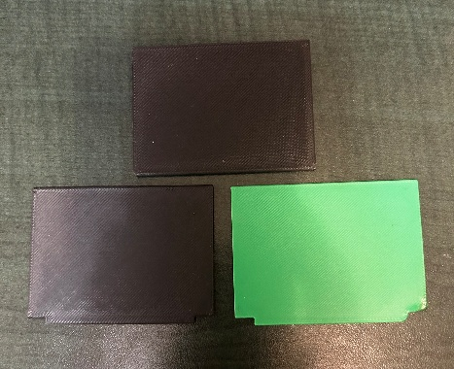
Figure 13: 3 prototypes of front plates. First prototype (top), second (right), final (left).

4.3.2 Roller Wheel
The team considered two design options for the ejection wheel: placing the wheel on top or underneath. The wheel was ultimately positioned underneath, as this configuration allowed gravity to assist in pulling the cards downward and made it easier to ensure that the system only distributed one card at a time (see Figure 10). This arrangement also provided a single, consistent exit point for the cards, rather than one that gradually shifted lower. In addition, placing the wheel underneath eliminated several complications associated with a top-mounted design, such as supporting the weight of the wheel, adjusting its position as cards were dispensed, and maintaining balance.

4.3.3 Weight
Despite the advantages of a bottom roller wheel, the chosen configuration introduced a new challenge. At the beginning of operation, the stack exerted excessive weight, while toward the end it provided too little, to a point where the last few cards would get stuck. This imbalance contributed to the decision to incorporate the front plate.
The group initially implemented an open-top design to simplify the insertion of cards, but it later served an additional purpose by allowing extra weight to be applied to the stack. The weight consists of two LEGO Technic steel balls stacked vertically, with the upper ball resting on the lower ball, which is in direct contact with the cards. Figure 14 shows the final weight configuration.
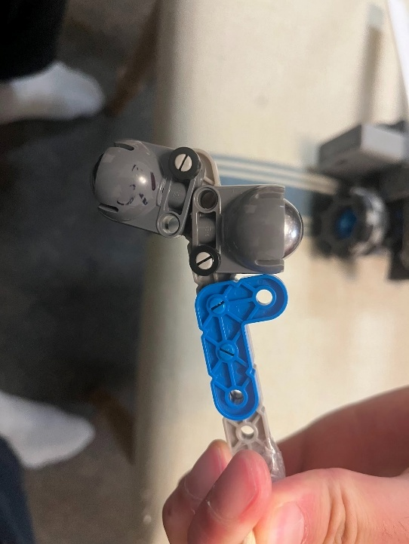
Figure 14: Final weight design.
The LEGO balls were selected both for their mass and for their ability to rotate freely in all directions, ensuring that they did not interfere with the ejection of the final card. The added weight resolved the issue of insufficient force on the last cards, which had previously prevented them from aligning with the slit formed by the front plate and the wheel. The placement of the weight, shown in Figure 15, was tested and chosen because it directed the combined weight of both balls toward the front of the stack near the center of the wheel. This configuration produced the most consistent results in assisting the cards as they exited the holder. The rod attaching the weight to the side plates, shown in Figure 15, was initially a VEX IQ axle rod. However, the available axle length was not suitable, and the rod occasionally slipped out of the holes. To address this, the group replaced it with a cut skewer, which provided the required length.
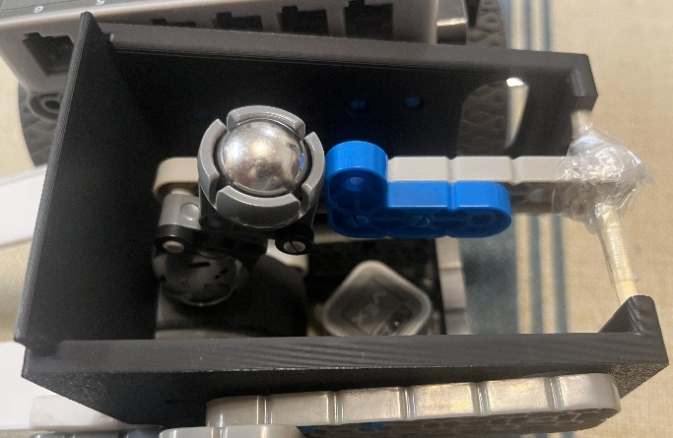
Figure 15: Weight placed on the center of the wheel and the front of where the cards would be placed with a skewer connecting it to the side plates

4.3.4 Rails
A consistent problem was the odometry system miscalculating because the robot was slipping on the already distributed cards. The cards were not being ejected far enough due to the lack of power from the VEX IQ motors. The ramp was created to solve this issue. The ramp, seen in Figure 16, is attached as seen in Figure 17 and consists of two long, angled rails designed to support and guide the cards away from the spin radius of the robot. These sloped rails were angled downward toward the front, allowing gravity to assist in maintaining card alignment and preventing unintended movement during operation. Each rail features a lip along the edge to keep the cards from sliding off the side of the rail. Errors occurred during the fabrication of one of the ramp plates, requiring modifications to ensure proper attachment. The current 3D‑printed version provided improved stability and alignment, contributing to a more dependable robot odometry. The group was initially hesitant to implement this idea because it conflicted with the requirement of being compact. However, the use of the ramp ended up being necessary due to the cards’ severe impact on the robot's odometry.

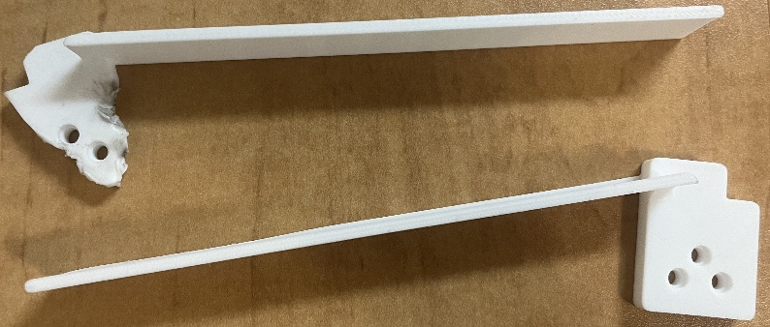
Figure 16: 3D printed ramp with attachment plates for securing to the robot (note the modifications made to the ramp on top)
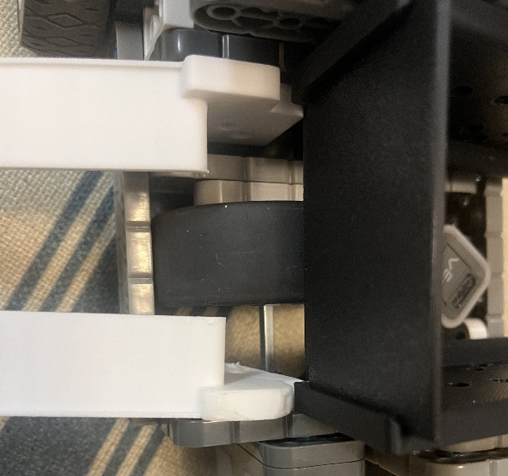
Figure 17: Ramps attached to the robot

5.0 Software Design and Implementation

5.1 Prototyping

5.1.1 Colour Sensor Hues
To receive more accurate readings for the assorted colors that could be involved, the group decided to get their own hues for each colour. The colour sensor was set at a fixed height pointed down and different coloured vex pieces and cards were slid underneath to get their hue readings. The values obtained are listed in the table below.

Table 2: Table of colour hues
Colour | Hue Range
White card | 0 or >345
Light grey vex part | 320 - 345
Dark grey vex part | 280 - 300
Blue card | 250 - 280

5.1.2 Distance Sensor Testing
There was an attempt to use the distance sensor to create a vision system and locate human players. The distance sensor would be mounted to a plate which could be rotated by a motor, allowing it to see in all directions. During testing, the team discovered that the sensor had trouble detecting heads consistently because the sensor’s angle was fixed but people’s heads were not all at the same height. Furthermore, it would occasionally confuse an object being closer as the object having become larger. Due to inconsistency of the distance sensor, it was scrapped early in the prototyping phase.

5.2 Overall Software Design

5.2.1 Software Summary
The software divided into four main subsystems: Control, UserInfo, Movement, and Distribution. The main() function served as the central controller and managed the execution flow aligning two different operating modes. Upon startup, the program initialized all hardware components and system state variables, then transitioned into the setup phase.
Setup
The user inputs the number of players and number of cards using the VEX IQ Controller/ Brain. Two modes could be selected when confirming the number of players:
- Location-based mode (confirmed using the F up button), where the robot used real-time odometry tracking to navigate to each player’s position. During setup, the user manually drove the robot to each player location and confirmed with button F up, which recorded the robot’s current coordinates and heading after confirming the number of cards. These positions were stored in memory and later used for autonomous navigation during distribution.
- Spinning-based mode (confirmed using the Brain Check button), where the robot remained stationary in its position and rotated by equal angular increments based on the number of players.
After the setup, the program waited for the user to press the TouchLED, which served as the start command for the card distribution sequence.
Once the distribution process began, the program executed differently depending on the selected operating mode. In location-based dealing, the robot navigated to each player's position using encoder-based odometry, driving autonomously to the stored coordinates recorded during the setup phase. Cards were then dispensed while the robot was positioned directly in front of the player and returned home when distribution was finished. In contrast, during spinning-based mode, the robot remained in a fixed position and rotated in place using inertial sensor. The system divided a full rotation by the number of players, and cards were dispensed at each angular interval to align the output direction with each player’s position.
The shutdown sequence was executed using the TouchLED. When the user pressed the TouchLED after the distribution process was completed, the optical sensor would detect whether cards remained in the deck. If no cards were detected, the program would shut down. Otherwise, the user was prompted on the screen: “Repeat dealing?”
- If No, the program would shut down.
- If Yes: another question would appear: Start over setup?
- if No: the robot restarts the distribution process using the previously stored inputs
- if Yes: the robot restarts operation at set up and new inputs are entered.

5.2.2 Final Task List
The final task list was designed to showcase the full extent and flexibility of the robot’s decision-flow logic. Multiple modifications were made to the original task list to account for changes in functionality and to show a more holistic picture of the robot’s performance. The remaining cards display was removed, as the robot could not determine the number of actual cards in the container. Instead, a more complex test was created to demonstrate the new shut down sequence. During Demo Day, the robot ran through the dealing process a total of four times. The additional runs were to used showcase both dealing modes, verify the robot’s data management between rounds, and that shutdown case was correctly executed under real operating conditions. The task list also included error handling tests to show the robot’s ability to reorient itself when pushed during distribution. A full-deck distribution to four players was timed to assess system efficiency under maximum card-distribution load. Finally, the team tested the robot’s behaviour regarding bumper sensor interruption to assess its ability to handle collisions, adhering to the original safety requirements.

5.2.3 Main Functions
bool Control::controllerSetup(UserInfo &userManager)
This function is responsible for recording all user-defined setup parameters before the card distribution process begins. It takes a reference to a UserInfo object as parameter and returns a boolean value, where true indicates that the user selected location-based operation and false indicates spinning-based operation. This is developed by Ho Yan Lam. Refer to Figure 18 for this section. During execution, default values for the number of players and cards are initialized, after the robot displays setup instructions on the VEX IQ Brain screen. The user adjusts the number of players using either the VEX IQ Controller buttons (EUp and EDown) or Brain buttons (Right and Left), when confirming the number of players, the user also selects the operating mode using either the FUp button (location-based distribution) or the Brain Checkmark button (spin-based distribution). The number of cards is then calculated automatically using the formula: 54 / players. If desired, the number of cards can be modified using the same input method. When both parameters are confirmed, they are stored using userManager.initializeUsers(players, cards) and a “Setup complete!” message is displayed. The function exits by returning the selected distribution mode, which directly determines the program flow in the main control structure. This function is essential for ensuring accurate player and card numbers are passed and the robot follows the correct logic branch into the appropriate operational pathway. (See function in Appendix B.1 on page 69)
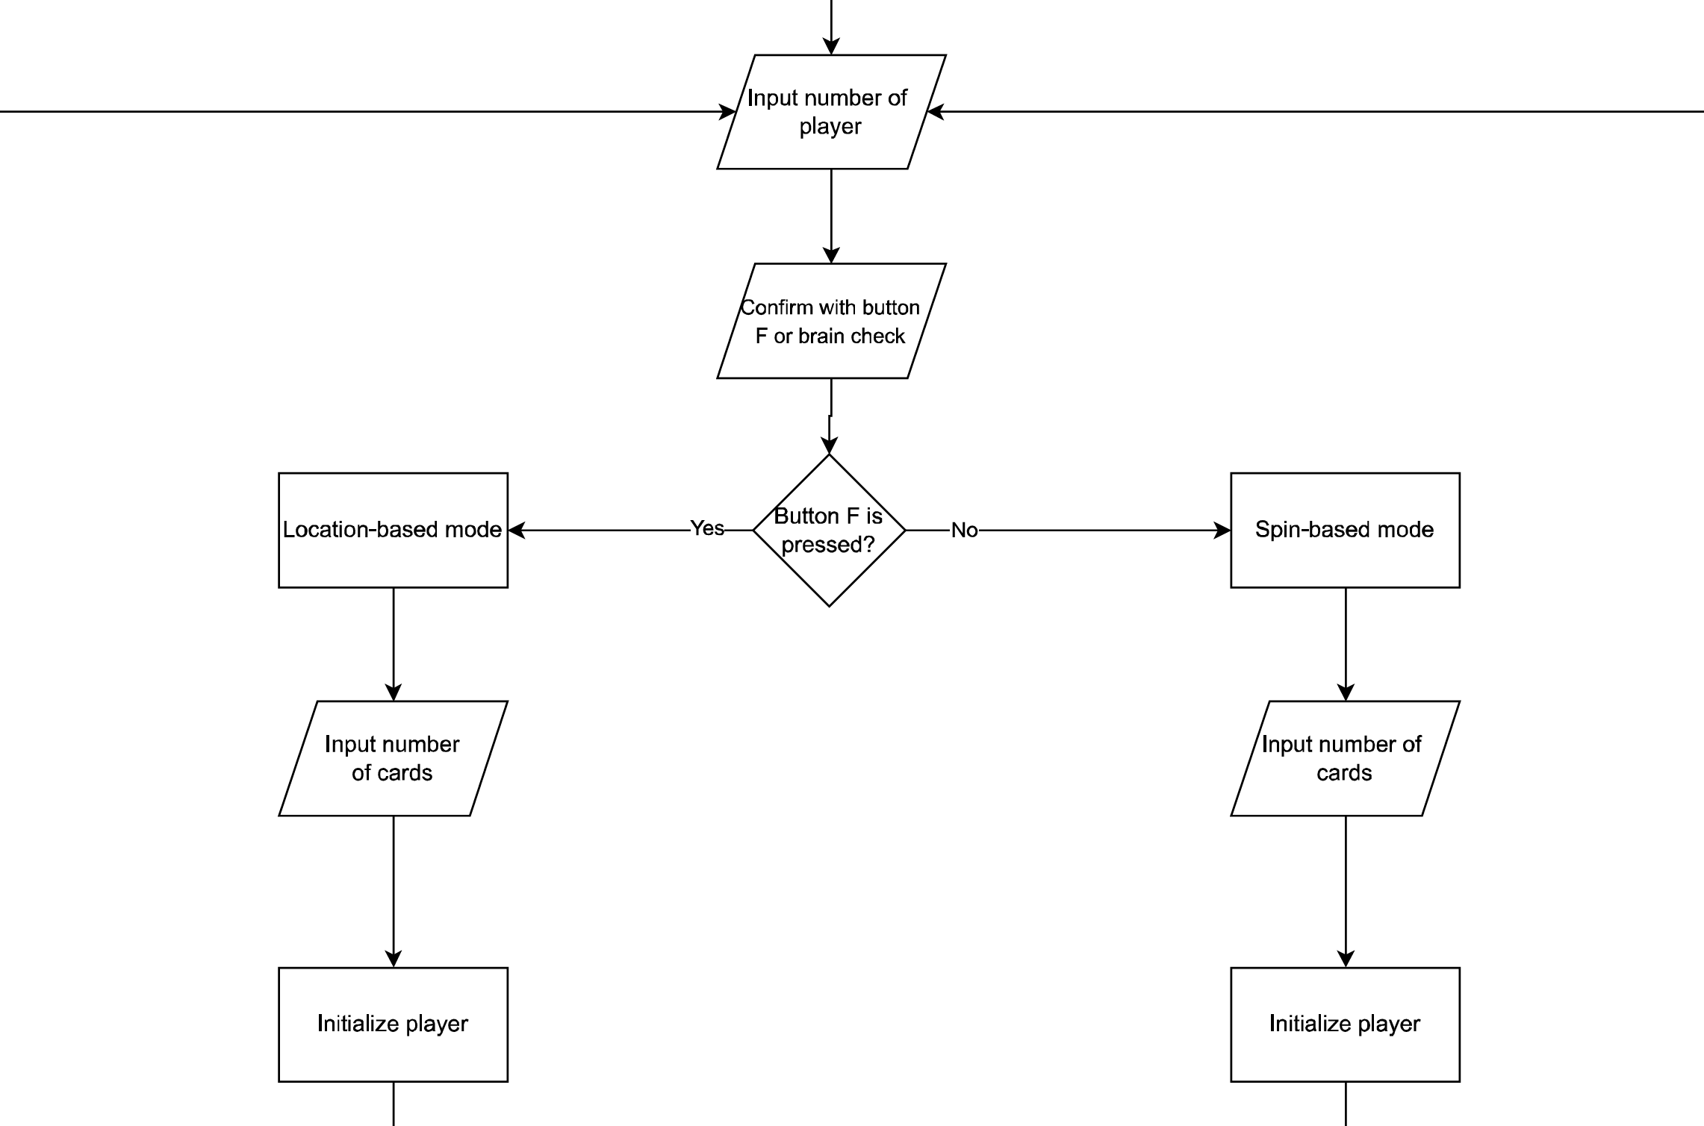
Figure 18: Flowchart for the setup stage
void Control::recordAllPlayerLocations(Movement &move, UserInfo &userManager)
This function is responsible for collecting and storing each player's position during the setup phase of location-based distribution. It takes two parameters, a reference to the Movement class for accessing driving and odometry functions, and a reference to UserInfo to store position data and it returns void as it performs state updates. This function is developed by Ho Yan Lam. Refer to Figure 19 for this section. The function begins by prompting the user with the VEX IQ Brain screen to manually drive the robot to each player's location using the joysticks. The translational and rotational input values are read from controller axes and processed using a deadband filter, after which left and right wheel speeds are calculated, and the robot is driven using move.driveStraight(). While the robot is being positioned, real-time odometry updates are continuously computed with move.locationUpdate(). When the user confirms the position using the Button FUp, the robot stops and the current odometry reading is saved using userManager.saveCurrentLocation(i) for the corresponding player index. This process is repeated for all players using a loop based on getTotalUsers(). After all positions are stored, a final confirmation message is shown on the VEX IQ Brain screen. This function corresponds to the player location initialization stage in the flowchart under Location-Based Setup, and it ensures accurate coordinates are stored for autonomous navigation during card distribution (See function in Appendix B.2 on page 73)
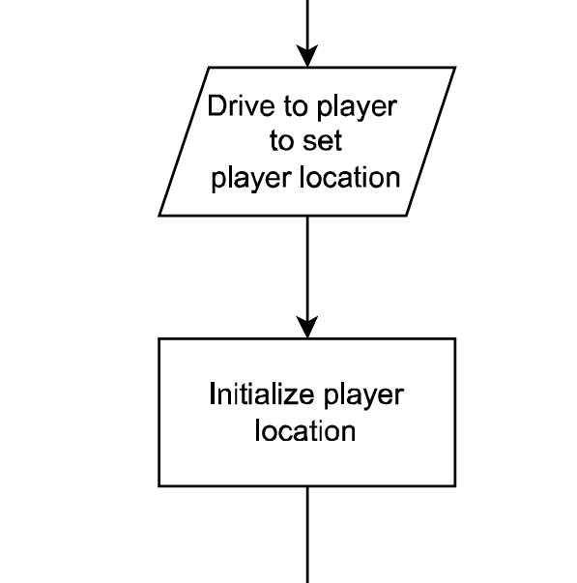
Figure 19: Flowchart for recording player locations
bool Control::endProgram(int &restartMode)
This function handles the program ending logic and manages user decisions once the card distribution process has finished. It accepts an integer reference parameter restartMode, which is used to indicate how the program should proceed with user input and is returned as either 0 (full shutdown), 1 (restart including new setup), or 2 (repeat distribution using the previous setup). The function returns a bool, with true indicating final shutdown and false indicating that the system should restart the distribution process. This is developed by Ho Yan Lam. Refer to Figure 20 for this section. This function first prompts the user with the VEX IQ Brain screen to press the TouchLED to proceed. After it is pressed, the program checks whether cards remain using the optical sensor. If no cards are detected, a shutdown message is displayed and the function returns true, signaling program shutdown. If cards remain, the user is asked if they would like to repeat the distribution process. If the user chooses to repeat, the function asks whether to restart the setup phase or retain the previously saved setup. If restartMode = 1, setup inputs are re-entered, if restartMode = 2, the current number of players and distribution settings are preserved in initializeUsers(). The function corresponds to the end program block in the flowchart, as it evaluates whether no cards remain, whether repetition is selected, and whether setup should restart or be reused. (See function in Appendix B.3 on page 75)
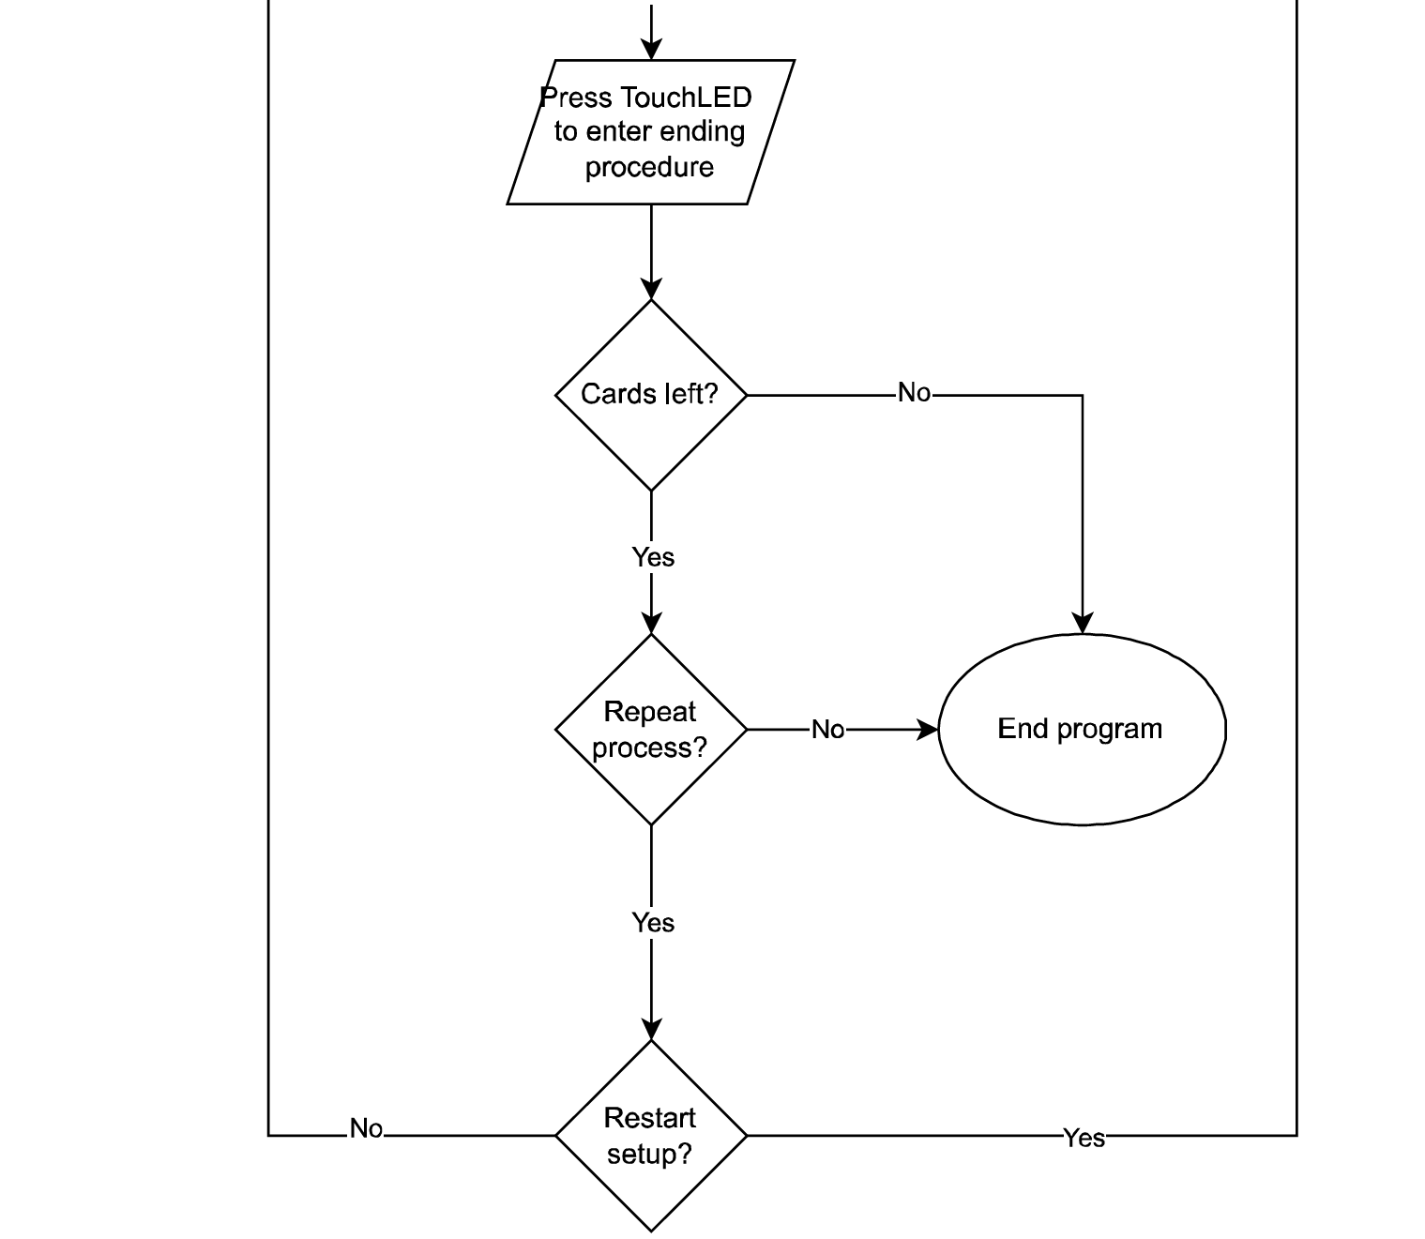
Figure 20: Flowchart for ending procedure
void Distribution::locDistribution()
This function manages the location-based card distribution process, where the robot autonomously travels to each recorded player position. This function does not take any parameters and does not return a value. This function is developed by Ho Yan Lam. Refer to Figure 21 for this section. The program begins by prompting the user to press the TouchLED. Once it is pressed, a shuffled array of player indices is created using randomPlayer() for randomized order of delivery. The function then enters a distribution loop that continues until all cards have been dispensed. For each player, the robot drives to the saved coordinates relying on odometry values previously recorded in recordAllPlayerLocations(). Upon arrival, the robot eject card by calling ejectCard() and updates internal tracking using user.cardGivenTo(). If countRemainingCards() returns zero, the distribution loop ends. The player order is reshuffled at the end of each round to maintain randomized dispensing logic. Once all cards have been distributed, the function prints a completion message and return to home position. (See function in Appendix B.4 on page 77)
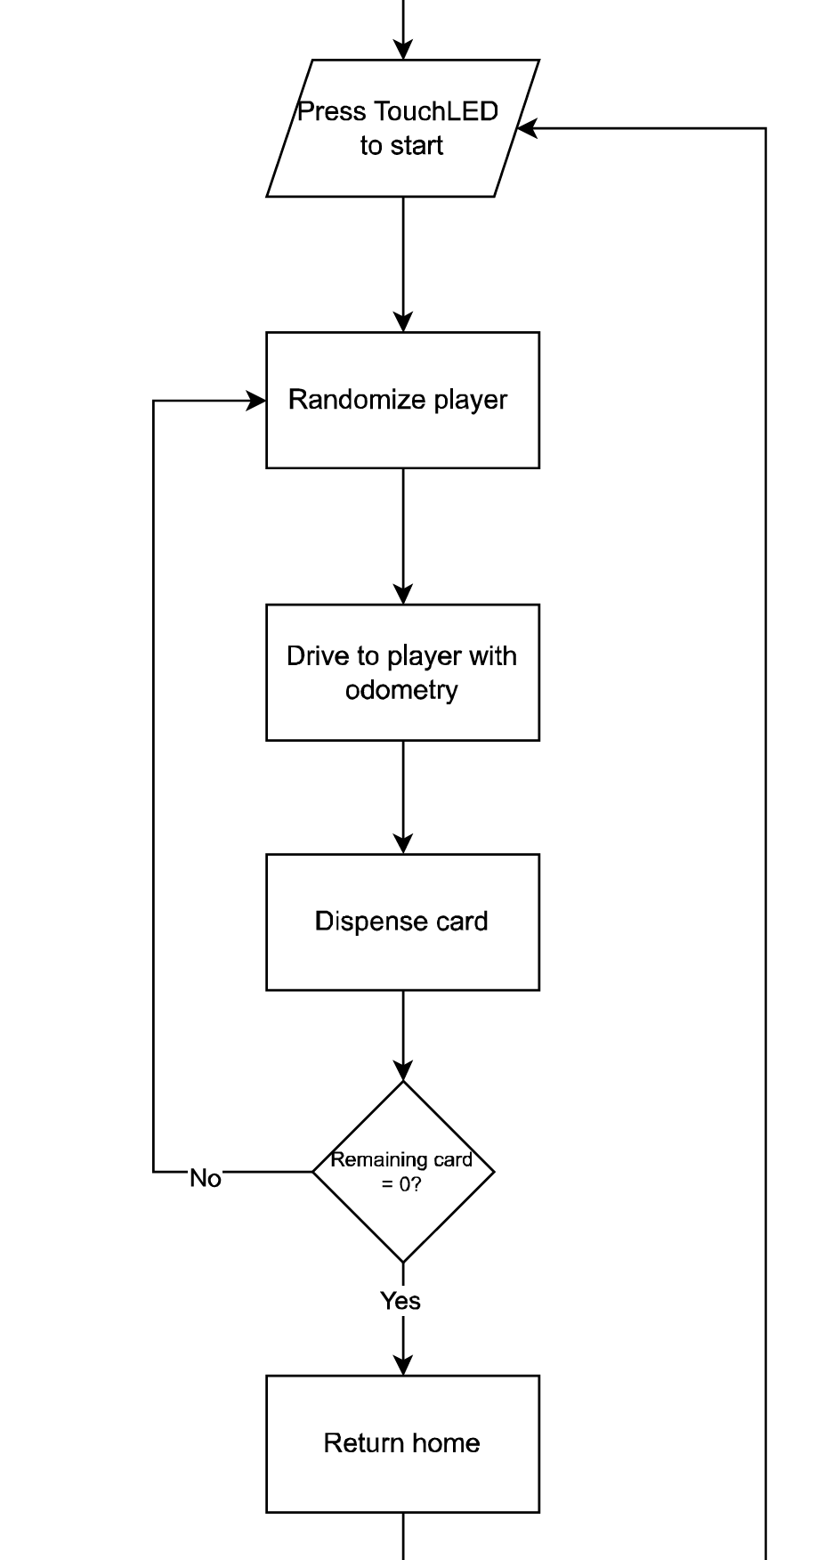
Figure 21: Flowchart for location-based distribution
void Distribution::spinDistribution()
This function handles the spinning-based card distribution mode, where the robot remains stationary and rotates in place to align card dispensing toward each player. This function takes no parameters and does not return a value. This is developed by Ruby. Refer to Figure 22 for this section. The function begins by resetting the display and prompting the user to press the TouchLED to start the operation. Once it is pressed, the program calculates the rotation interval using the equation angleIncrement = 360 / totalPlayers, allowing the robot to divide a full rotation equally based on the number of players. Then the program loops until all cards have been dispensed. Within each cycle, the robot rotates to each player using spinToDegree(), which uses calculated heading values determined by multiplying the angle increment with the corresponding player index. After alignment, ejectCard() is called to dispense a card, and user.cardGivenTo(i) is used to update card-tracking data. Card status is continuously checked with countRemainingCards(), and once the total reaches zero, distribution stops. (See function in Appendix B.5 on page 79)
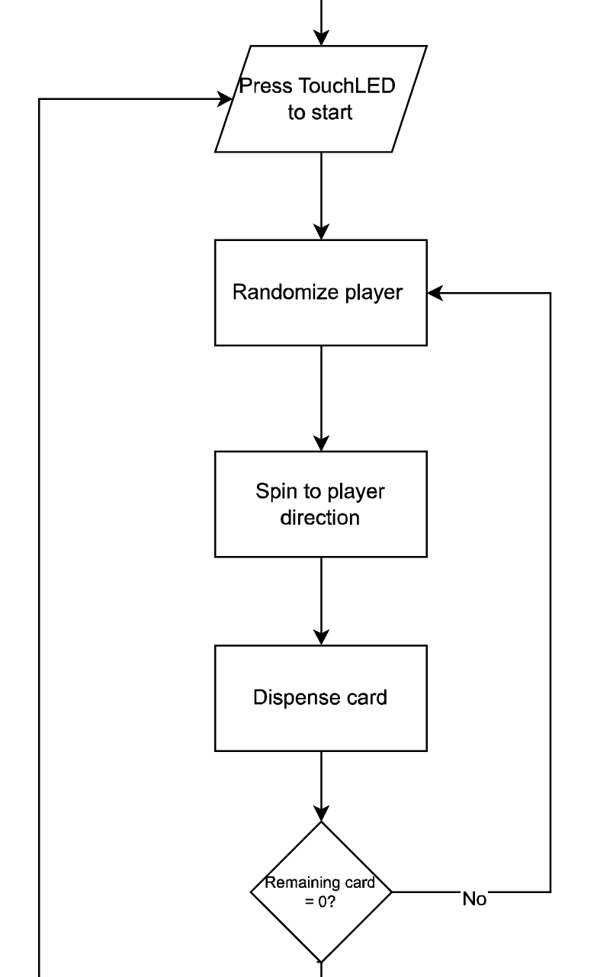
Figure 22: Flowchart for spinning-based distribution

5.2.4 Data Storage
All player-related data is managed through the UserInfo class, which is responsible for storing the number of players, their individual card counts, and their coordinates for location-based distribution. Internally, the program uses fixed-size arrays to store data for up to seven users. The users[] array keeps track of how many cards each player still needs to receive. The userLocation[3][MAX_USERS] array stores each player’s recorded position using three floating-point values, the x-coordinate, y-coordinate, and heading angle. The initializeUsers(int players, int cards) function saves the total number of users and assigns the initial number of cards for each player while cardGivenTo(int userID) decreases the value in the users[] array once a card has been successfully dispensed. Player positions are recorded using saveCurrentLocation(int idx), which stores the robot’s current odometry-based position receiving from the Movement class. These values are used during autonomous distribution to navigate accurately to each player’s location. This data-handling process corresponds to the setup phase in the flowchart, as it ensures that user input and location data are saved for later distribution. (See class in Appendix A.5 page 66)

5.3 Movement Class
This is the class co-developed by Tian Ma and Eric Zhang, which contains all functions for controlling and tracking robot movement. This class was implemented as the “core” class, meaning it does not require any of the other classes to function. As a result, other classes can call functions in the Movement class, however the Movement class cannot call on other functions. Aside from getters, there are only 5 primary functions that are public. These functions control all movement within each phase or mode of the robot. The class overview is shown in Table 3 below.
Table 3: UML diagram of the Movement class
Movement
-MotorLeft : motor
-MotorRight : motor
-BrainInertial : inertial
-Bumper : bumper
-wheelCircumference : const double
-wheelBase : const double
-location : double[]
-arcRatio(int radius) : const float → inline
-findTangent(float centerX, float centerY, float radius) : const float → inline
-normalizeAngle(float targetAngle, float cwLimit) : const float → inline
-finalAngleCheck(float finalAngle, float error): const bool → inline
-smooth(float difference, float a, float b): float → inline
-accelerate(float currentSpeed, float targetSpeed): float → inline
+getX() : const float → inline
+getY() : const float → inline
+getHeading() : const float → inline
+moveTo(float x, float y, float finalAngle, float speed) : void
+driveStraight(double rightMotorSpeed, doubleLeftMotorSpeed) : void
+spinToDegree(double motorSpeed, double angle) : void
+locationUpdate() : void
+stopMotors() : void

Class development: The Movement class and related functions were initially conceptualized based on a coordinate system. For this system to work, the reliability of the odometry system had to be rigorously tested. Backup movement systems were developed alongside the odometry based system, including simpler, rotation-based distribution.
Class Parameters
Within the constructor for the class, there are 4 parameters for the class to take in, being leftMotor, rightMotor, BrainInertial, and Bumper. These parameters are the only information that the movement class needs to interpret its surroundings and location.
Class variables
There are 7 variables that span the whole class shown in Table 3. Firstly, the most important is the location array, which stores x and y coordinates, and is only updated by the locationUpdate() function. Furthermore, there is also the wheelCircumference variable which does not impact how the robot interprets its surroundings but serves as a helpful way to convert the robot’s coordinates into cm. The wheelBase parameter is a constant representing the measured distance between the center of each drive wheel. This parameter allowed the robot to calculate the ratio of outer to inner wheel speed to drive in an arc of a set radius. Finally, 4 other variables that are associated with motor and sensor control/input were required due to the class being defined in a separate header file.
Private functions
These functions served as helper functions for the public functions. All were chosen to be inline functions because of their simplicity and use in high-speed environments, where the small increase in file size and compilation was considered a worthwhile compromise for faster run speeds.
arcRatio(int radius) const
This function is constant because it does not modify any values in the class. It returns the result of the equation in Figure 23 which calculates the desired speed ratio between wheels for the inputted radius. The output is a float as the accuracy of a double was not needed in circumstances where other errors were far greater than the precision of a float.

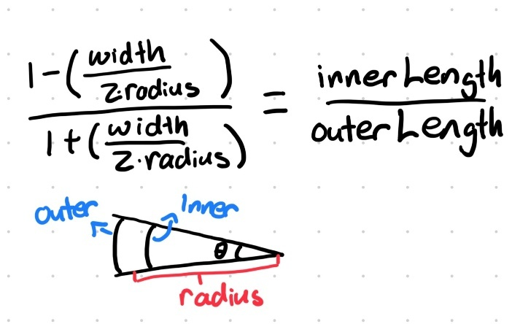
Figure 23: Equation and visual representation of smooth() function
float findTangent(float centerX, float centerY, float radius) const
This function takes in x and y coordinates corresponding to the center of a circle with inputted radius r. The output represents the angle difference between the robot heading and the left tangent of the circle in degrees given by Figure 24. The function is constant because it does not modify any values in the class.
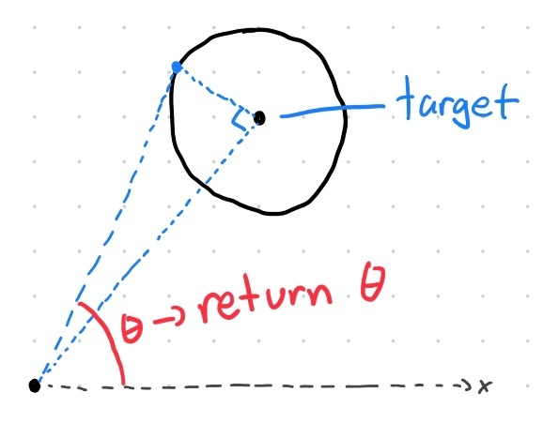
Figure 24: Visual representation of findTangent() function
float normalizeAngle(float targetAngle, float cwLimit) const
This function is extremely important to the overall decision making of the movement-based distribution. It takes in a target angle from [0,360) and a maximum tolerance for clockwise turns in degrees. The function then returns the signed angle between the robot and the target, with negative returns corresponding to clockwise turns while positive returns correspond to counterclockwise turns by the magnitude of the return. The function prevents the wrapping of heading from providing inappropriate angles.

bool finalAngleCheck(float finalAngle, float error) const
When called, the function takes in arguments for the desired angle and acceptable error in degrees. It then checks to see if the robot heading is within an acceptable angle tolerance relative to the finalAngle argument and returns the result in a boolean.
float smooth(float difference, float a, float b)
This function attempts to smooth deceleration for the robot through the equation shown in Figure 25, where “x” represents the difference in angle and parameters “a”, “b” being the tuned parameters. “a” is the specific value being tuned and “b” is the acceptable minimum speed. The function has a limit of y = 1 which prevents invalid outputs. “a” and “b” are given as arguments as each use of the function required different tuning to be efficient. Smoothing deceleration prevents excess wheelspin and overshoots which subsequently improves the accuracy of odometry and dealing.
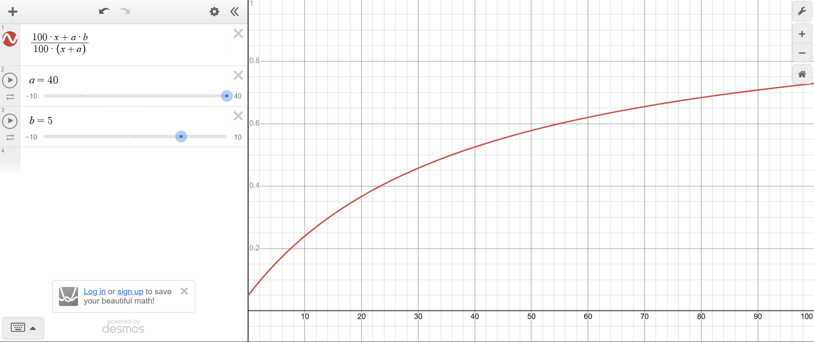
Figure 25: Graph representing the equation found in the smooth() function
float accelerate(float currentSpeed, float targetSpeed)
This function provides smooth acceleration during odometry based distribution. It takes the current speed of the robot and a target speed under the assumption that the robot is attempting to accelerate and increases the speed of the robot until it matches the desired speed in a smooth manner.
void getX(), void getY()
These two functions return the float value of the x, y coordinates stored in location[], in cm.

void getHeading()
This function was necessitated because of the difference in VEX IQ and trigonometry functions. While VEX IQ treats an increase in heading as a clockwise rotation, trig functions associate this increase in a counterclockwise manner. As a result, converting the robot heading into trigonometric form was a necessary fix to allow trigonometric functions to work.
void stopMotors()
This function commands both drive motors to stop.
void Movement::driveStraight(int leftMotorSpeed, int rightMotorSpeed)
This function was designed by Eric Zhang to drive the robot drive straight forward. The function takes in two parameters, one for each motor, to control motor velocity and stops when the bumper is pressed.
void Movement::spinToDegree(double motorSpeed, double angle)
This function was developed by both Tian Ma and Eric Zhang. Although its logic appears to be trivial, the final implementation was rather complex (seen in Figure 26). The primary issue was deciding which direction the robot needed to spin. normalizeAngle() was developed to solve the problem, as well as smooth() to prevent overshooting. Furthermore, there is code to detect if the bumper is being pressed, which stops the spinning until the object is removed.
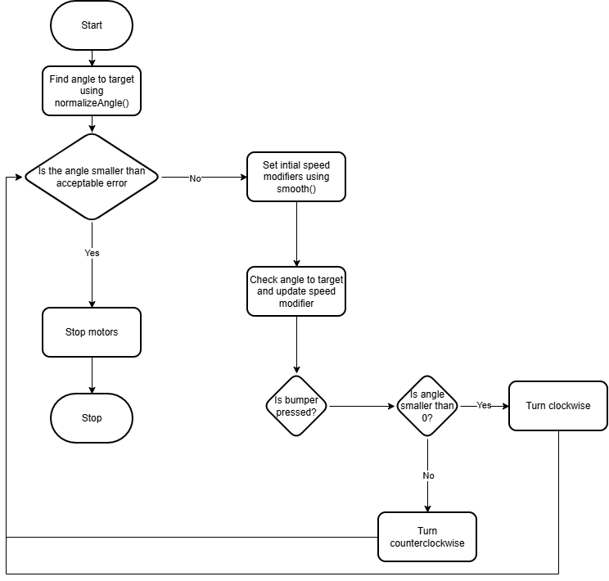
Figure 26: Flowchart for spinToDegree() function
void Movement::locationUpdate()
This function is the basis of all odometry-based movement for the robot. Its implementation was originally thread-based, however changes were made to allow it to work without threads. The function was created to run as fast as possible within the group’s knowledge of coding, however it was not implemented inline due to its length. Linear drive testing revealed that the robot was undershooting its distance travelled, however this was determined to not be an issue as all distances were consistently being undershot, meaning there was no accuracy errors associated with this issue. Rotational tests revealed similar results as well, so the locationUpdate() function was determined to be capable of accurately updating the location of the robot. Refer to Figure 27 for the function process.
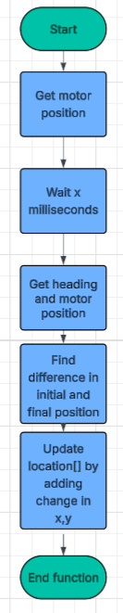
Figure 27: Flowchart for locationUpdate() function
void Movement::moveTo(float centerX, float centerY, float finalAngle, float speed)
This function is one of the longest for the robot. Although it can technically be split into 3 independent stages, it was determined that creating subfunctions was not necessary, as the unique movement code would not be implemented anywhere else in code or in the future. This function was extensively tested through various test runs and could navigate within 30cm of the target over repeated runs. It must be noted that the accuracy of movement was heavily biased towards the last target set, with no significant deviation of card distribution found. Further analysis should be conducted on reducing sources of error. Refer to Figure 28 and Figure 29 for the logic behind this function.
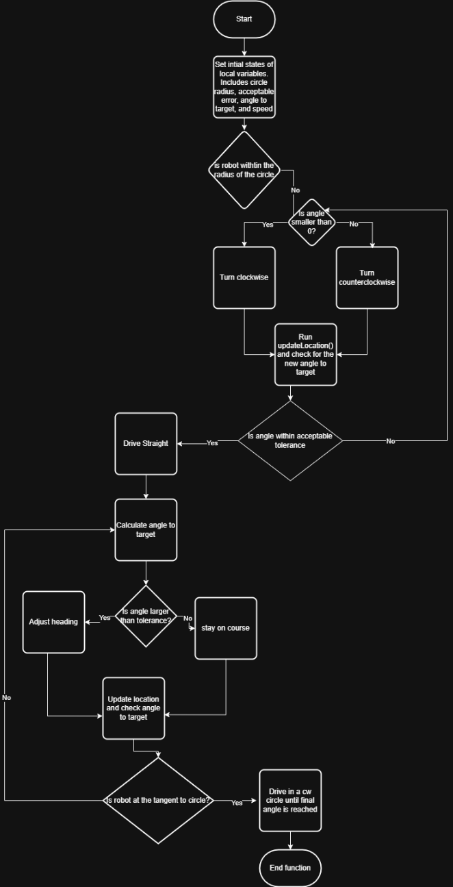
Figure 28: Flowchart for moveTo() function
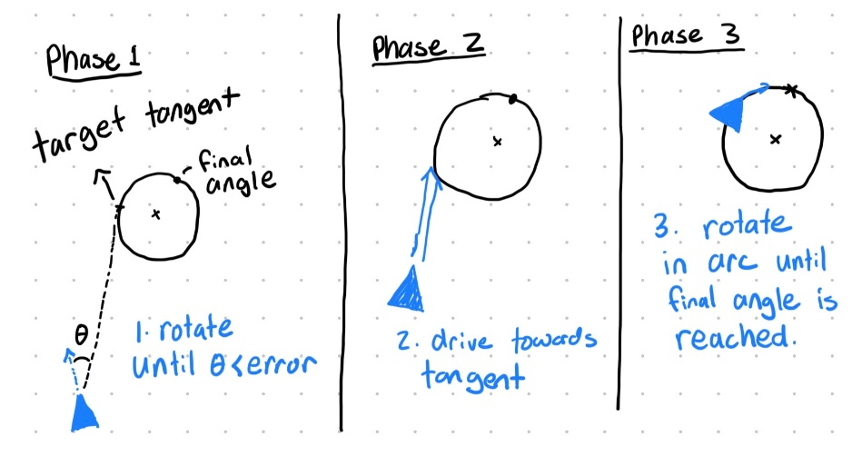
Figure 29: Phases of moveTo() function

5.4 Card Ejector
All functions pertaining to card ejection and distribution are found in the Distribution class, which is the final class of the program. This class takes in all other classes including Movement, UserInfo, and Control, as well as other parameters found in Appendix A.3.
void Distribution::locDistribution()
This function manages the location-based card distribution routine, where the robot autonomously travels to each recorded player position using odometry before dispensing cards. This function does not take any parameters and does not return a value. The function begins by prompting the user to press the Touch LED, which serves as the start signal for distribution.
void Distribution::spinDistribution()
This function handles the spinning-based card distribution mode, where the robot remains stationary and rotates in place to align card dispensing toward each player. This function takes no parameters and does not return a value.
void Distribution::randomPlayer(int players[], int size)
This function replaces previous shuffling functions with a Fischer-Yates shuffle algorithm[1]. Because the base logic for this function was not created by the group, this function should be omitted from grading.
void Distribution::ejectCard()
This function ejects one card based on measured values. It first spins the ejection motor forward for the length of a card (91mm). Afterwards it spins in reverse for a set amount of time to retract excess cards that may have been ejected. Because ejection values were previously measured, this function does not take in or return any values.

6.0 Verification
During the final demonstration, the robot met almost all of the updated requirements and constraints required for the project. In operation, the system was able to deal a deck of 52 cards to four players in 1 minute and 36 seconds. This exceeds the performance expectation for rapid card distribution, defined as one of the robot’s requirements. Clear, on-screen user prompts were displayed on the brain to guide setup and operational interactions, fulfilling communication requirements for usability. For the location-based mode, players were able to drive the robot manually and save their positions. The stored coordinates were confirmed to be reasonable and reproducible, based on odometry readings. Randomness in card distribution order was confirmed by observing three test runs, each resulting in a different player sequence, demonstrating that the distribution logic does not follow a fixed pattern. The robot correctly differentiated between location-based and spin-based modes, which was selected by either pressing the FUp button on the controller, or the checkmark button on the VEX IQ brain. Regarding mechanical performance, the robot was programmed to dispense exactly one card at a time, achieved through a controlled forward-reverse motor sequence to prevent multi-card release. Additionally, the card holder was custom 3D-printed with a narrow slot specifically dimensioned to allow only one card to slide through at a time. The requirement for the robot to fit within a 30 × 20 × 20 cm volume was not met. The final robot exceeded the 20cm width dimensions after external ramps were added. These ramps were introduced late in the design process to improve card alignment and ensure smoother ejection, but this modification unintentionally increased the robot’s overall size beyond the original limits. To improve the design to meet the constraint, the ramp mechanism could be redesigned to be integrated internally within the chassis so that card guiding performance is maintained without exceeding the size constraint or reducing portability.

7.0 Project Plan
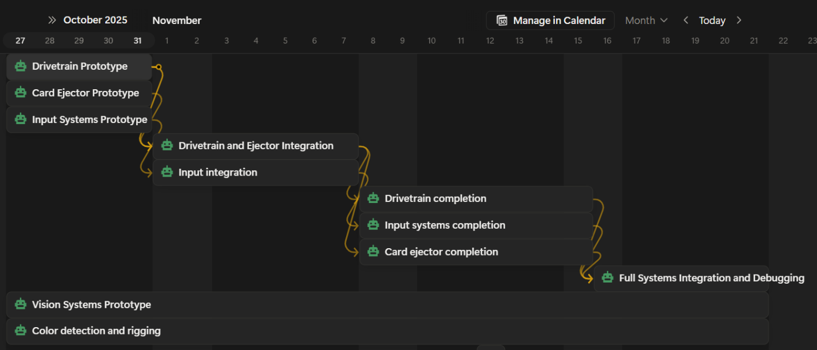
Figure 30: Gantt chart for project

7.1 Task Division
The ideation and prototyping phases were done together as a group so that every member would have a clear idea about how the robot would function. (For more information about the prototyping, read sections 4.1 and 5.1). The final concept was decided based on the extent of which each method aligns to the robot’s requirements and constraints. After the overall design of the robot was solidified, the group divided tasks based on each member’s personal interests. The project management was done on Notion to help track progress. The team recognized that the scope of the additional features for the robot was not entirely feasible. As such, tasks were divided into “high”, “medium”, and “low” priority. Low priority tasks were those that were not necessary to complete the project but simply interesting add-ons for the group to implement as they saw fit. This system allowed flexibility and for team members to explore their own interests. Ruby worked on the controls system, code integration, and experimented with the possibility of a card rigging feature. Ho Yan Lam programmed the distribution subsystem and handled the robot’s internal logic and processes. Tian handled the development of the robot’s odometry system, from the base code to fine-tuning formulas, and tested the feasibility of a vision system. Eric took charge of the robot’s mechanical components and programmed the base drivetrain.

7.2 Revisions to Project Plan
The project deadlines were moved ahead by two days as the team realized one of their members had an extracurricular that would make them unavailable for the majority of the final week before demo day. This adjustment was not too difficult, as prototyping was going smoothly and some tasks were completed ahead of schedule. However, the card rigging feature had to be abandoned due to the member’s absence. Although the group fell slightly behind schedule, the earlier completion date they had set for themselves gave them flexibility. The project was successfully completed within the period set by the course.

8.0 Conclusions
The objective of this project was to design and develop an automated card-dealing robot capable of efficiently distributing cards to multiple players. The problem addressed was the need to automate card distribution in a fast and fair way without manual handling. To solve this, the robot was required to manage player order, dispense cards individually, and react based on user input. The final system demonstrated successful integration of mechanical, electronic, and software components to achieve this functionality.
While the robot did not fully meet the 30 × 20 × 20 cm size constraint, it remained lightweight and portable. The design used two drive motors and one dedicated card-ejection motor, paired with a custom 3D-printed card holder featuring a narrow slot that ensured only one card could exit at a time, supported by a controlled forward–reverse ejector motor sequence to prevent multi-card release. During testing, the robot achieved fast dealing speed, satisfying the intended performance requirement. It was operated on a moderately textured surface to avoid wheel slippage or odometry drift, and the system was limited to a maximum of seven players because smaller angular divisions during spinning-based mode increase the chance of overlapping card piles. The robot was also used in well-lit, open environments to maintain reliable optical sensor readings and ensure the location-based mode had sufficient space for accurate navigation.
On the software side, the system successfully handled different configurations of dealing mode, number of players, and number of cards. The program stored real-time odometry data to record player coordinates in location-based mode and used angular distribution logic in spinning-based mode. The end program function allowed the user to either shut down, repeat using existing data, or restart setup, demonstrating flexibility and matching all shutdown paths shown in the flowchart. The core logic worked correctly during development and internal trials.
Most major project constraints were successfully satisfied. The robot operated at fast speed, displayed correct user instructions, saved player coordinates, dispensed one card at a time, and differentiated correctly between operating modes all within surface, lighting, space, and player limit restrictions. Both mechanical and software components worked together cohesively to meet the project goals.
Ultimately, the robot successfully addressed the original problem of automating card distribution using a combination of engineered hardware design and structured software logic.

9.0 Recommendations

9.1 Mechanical Recommendations
If the chassis was 3D-printed, the robot could be made more compact as VEX IQ parts made it difficult to make the robot smaller. The VEX IQ motors could be replaced with smaller, more powerful motors, which would improve the speed of the robot. The railings could also be better integrated into the overall design, so they do not protrude as much. With more time, it would be nice to experiment with different materials to increase grip on the roller wheel. This could increase the robot’s consistency and speed. Finally, it would be nice to add a shuffler system to the card dealer. This would require a complete mechanical overhaul and lots of additional time, but the resulting robot will be much more convenient for user while reducing the need for complex movement systems found in Section 5.3.

9.2 Software Recommendations
The structure of the current code base would be confusing to people who are not involved in the development process. It would make the code more robust to reformat the header files and include more comments with explanations regarding the process behind each function. To make the controls system even more user friendly, the team would implement a back button in case the user made a mistake when inputting the information. Additionally, the option between spin-based and odometry-based distribution would be made into its own separate question during the setup process. Even though the display informs the user about what the two different confirmation buttons entail, the user may find there are too many words and not read the instructions, only to be left confused.

References

[1] | "Fisher–Yates shuffle," Wikipedia, [Online]. Available: https://en.wikipedia.org/wiki/Fisher%E2%80%93Yates_shuffle. [Accessed 1 December 2025].

Appendices

Appendix A.1: The Main File

/*----------------------------------------------------------------------------*/
/* */
/* Module: main.cpp */
/* Author: tianm */
/* Created: 11/18/2025, 6:58:11 PM */
/* Description: IQ2 project */
/* */
/*----------------------------------------------------------------------------*/
#include "vex.h"
#include "movement.h"
#include "userInfo.h"
#include "control.h"
#include "distribution.h"

using namespace vex;

// Define inputs and outputs
motor MotorLeft = motor(PORT11, false);
motor MotorRight = motor(PORT8, true);
motor MotorOutput = motor(PORT10, false);
touchled TouchLED = touchled(PORT9);
optical Optical = optical(PORT7);
brain Brain = brain();
inertial BrainInertial = inertial();
controller Controller = controller();
bumper Bumper = bumper(PORT12);

// define your global instances of motors and other devices here
void initializeRandomSeed()
{
wait(100, msec);
double xAxis = BrainInertial.acceleration(xaxis) * 1000;
double yAxis = BrainInertial.acceleration(yaxis) * 1000;
double zAxis = BrainInertial.acceleration(zaxis) * 1000;
// Combine these values into a single integer
int seed = int(
xAxis + yAxis + zAxis);
// Set the seed
srand(seed);
}

void vexcodeInit()
{
// Initializing random seed.
initializeRandomSeed();
}

void configureAllSensors()
{
BrainInertial.calibrate();
wait(2, seconds);
BrainInertial.setHeading(0, degrees);
BrainInertial.setRotation(0, degrees);
MotorLeft.setPosition(0, turns);
MotorRight.setPosition(0, turns);
Optical.setLight(ledState::on);
// might want to add a wait here to ensure calibration is done
}

int main()
{
// Initializing Robot Configuration. DO NOT REMOVE!
vexcodeInit();
// Begin project code

// Initialize robot and objects
configureAllSensors();

Movement move = Movement(MotorLeft, MotorRight, BrainInertial, Bumper);
UserInfo user = UserInfo(&move);
Control control = Control(user, move, Brain, Controller, TouchLED);
Distribution distribution = Distribution(move, user, control, MotorOutput, TouchLED, Optical, Brain);

bool runProgram = true;
int restartMode = 0;
bool lastLocBased = true;

while (runProgram)
{
bool locBased = lastLocBased;
if (restartMode == 0 || restartMode == 1)
{
control.resetScreen();
bool isRigged = false;
locBased = control.controllerSetup(user);
lastLocBased = locBased;

if (locBased)
{
control.recordAllPlayerLocations(move, user);
}
}

control.resetScreen();
Brain.Screen.print("Starting...");
wait(1, seconds);

if (locBased)
{
distribution.locDistribution();
}
else
{
distribution.spinDistribution();
}

bool stop = control.endProgram(restartMode);

if (stop || restartMode == 0)
{
runProgram = false;
}
else
{
runProgram = true;
}

wait(200, msec);
}

Brain.programStop();
}

float UserInfo::findMean(float arr[], int n) const
{
int totalCount = 0;
for (int i = 0; i < n; i++)
{
totalCount += arr[i];
}
totalCount /= n;
return totalCount;
}

void UserInfo::resetCards()
{
for (int i = 0; i < totalUsers; i++)
{
users[i] = cardsPerPlayer;
}
}

void UserInfo::adaptCenter(int radius)
{
// find center
float centerX = findMean(userLocation[0], totalUsers);
float centerY = findMean(userLocation[1], totalUsers);

// for each x,y pair, find new coordinates, update x y
for (int i = 0; i < totalUsers; i++)
{

// find the distance for x and y to the center
float dx = centerX - userLocation[0][i];
float dy = centerY - userLocation[1][i];
float d = hypot(dx, dy);

// exit if too close
if (fabs(d) < radius)
{
return;
}

// normalize the changes. This represents how much of the radius is actually being applied to each vector
float nx = dx / d;
float ny = dy / d;

// modifies original array values
userLocation[0][i] += radius * nx;
userLocation[1][i] += radius * ny;
}
}

// Movement Class Public

void Movement::moveTo(float centerX, float centerY, float finalAngle, float speed = 100)
{
const int lastRadius = 10; // cm radius of arc to turn
const int distError = 3; // acceptable cm error
const int angleError = 5;
float deltaAngle = normalizeAngle(findTangent(centerX, centerY, lastRadius), 270);
float lastSpeed = 0; // int used to smooth speed
float speedRatio = arcRatio(lastRadius);

if (hypot((location[1] - centerY), (location[0] - centerX)) < (distError + lastRadius)) // if we are too close, end function
{
MotorLeft.stop();
MotorRight.stop();
return;
}

if (deltaAngle > 0) // needs to turn cww
{
MotorLeft.setVelocity(speedRatio * lastSpeed, percent);
MotorRight.setVelocity(lastSpeed, percent);
}
else // needs to turn cw
{
MotorLeft.setVelocity(lastSpeed, percent);
MotorRight.setVelocity(lastSpeed * speedRatio, percent);
}

MotorLeft.spin(forward);
MotorRight.spin(forward);

// Wait until we are tanget to circle
while (fabs(deltaAngle) > angleError)
{
lastSpeed = accelerate(lastSpeed, speed);
if (deltaAngle > 0) // needs to turn cww
{
MotorLeft.setVelocity(speedRatio * lastSpeed, percent);
MotorRight.setVelocity(lastSpeed, percent);
}
else // needs to turn cw
{
MotorLeft.setVelocity(lastSpeed, percent);
MotorRight.setVelocity(lastSpeed * speedRatio, percent);
}
// updates odometry and find a new tangent based on updated location
locationUpdate();
deltaAngle = normalizeAngle(findTangent(centerX, centerY, lastRadius), 270);
}

lastSpeed = speed;
MotorLeft.setVelocity(lastSpeed, percent);
MotorRight.setVelocity(lastSpeed, percent);

// int courseCorrection = 1 - smooth(deltaAngle, 20, 5);
while (hypot((location[1] - centerY), (location[0] - centerX)) > (distError + lastRadius) && abs(deltaAngle) < 90)
{
if (fabs(deltaAngle) < angleError) // on course
{
MotorLeft.setVelocity(lastSpeed, percent);
MotorRight.setVelocity(lastSpeed, percent);
}
else if (deltaAngle > 0) // needs to turn ccw
{
MotorLeft.setVelocity(lastSpeed * 0.9, percent);
MotorRight.setVelocity(lastSpeed, percent);
}
else // needs to turn cw
{
MotorLeft.setVelocity(lastSpeed, percent);
MotorRight.setVelocity(lastSpeed * 0.9, percent);
}

// update odom
locationUpdate();
deltaAngle = normalizeAngle(findTangent(centerX, centerY, lastRadius), 270);
// courseCorrection = 1 - smooth(abs(deltaAngle), 100, 0);
}

// Brain.Screen.print("phase4\n");
// Enters final arc to drive in
while (finalAngleCheck(finalAngle, angleError))
{
// lastSpeed *= smooth(fabs(normalizeAngle(finalAngle, 359)), 40, 5);
MotorLeft.setVelocity(lastSpeed, percent);
MotorRight.setVelocity(lastSpeed * speedRatio, percent);
locationUpdate();
}
// stops motors to ensure that odometry remains accurate)
// DELETE THESE IF WE ARE NOT STOPPING AFTER MOVE TO

MotorRight.stop();
MotorLeft.stop();
}

void Movement::locationUpdate()
{
double waitTime = 10; // ms (ADJUST AS NEEDED)

// Initial Values
double lastLeft = MotorLeft.position(turns);
double lastRight = MotorRight.position(turns);
double lastCenter = (lastLeft + lastRight) / 2.0;

wait(waitTime, msec); // wait before starting updates

// Final Values
double currentLeft = MotorLeft.position(turns);
double currentRight = MotorRight.position(turns);
double currentCenter = (currentLeft + currentRight) / 2.0;
double currentHeading = (360 - BrainInertial.heading(degrees)) * (M_PI / 180.0);

double deltaCenter = (currentCenter - lastCenter) * wheelCircumference;

// Updates values of x and y
location[0] += deltaCenter * cos(currentHeading); // x
location[1] += deltaCenter * sin(currentHeading); // y
}

void Movement::driveStraight(double rightMotorSpeed, double leftMotorSpeed)
{
if (!Bumper.pressing())
{
MotorLeft.setVelocity(leftMotorSpeed, percent);
MotorRight.setVelocity(rightMotorSpeed, percent);
MotorLeft.spin(forward);
MotorRight.spin(forward);
// AGAIN NOT SURE IF THIS WORKS HOW I WANT IT TO
// odom.locationUpdate();
// wait(20, msec);
}
else
{
MotorLeft.stop();
MotorRight.stop();
}
}

void Movement::spinToDegree(double motorSpeed, double angle)
{
// ODOMETRY DOES NOT MATTER FOR THIS
// motorSpeed -=5; //subtract five because of velocity adjustment formula
const float angleError = 3;
float deltaAngle = normalizeAngle(angle, 180); // finds the angle needed to turn to the spot
if (fabs(deltaAngle) < angleError)
{
MotorLeft.stop();
MotorRight.stop();
return; // already at angle
}

float smoothFactor = smooth(fabs(deltaAngle), 40, 5);
MotorLeft.setVelocity(motorSpeed * smoothFactor, percent);
MotorRight.setVelocity(motorSpeed * smoothFactor, percent);

// check which direction we need to rotate
if (deltaAngle < 0) // turn cw
{
MotorLeft.spin(forward);
MotorRight.spin(reverse);
}
else
{
MotorLeft.spin(reverse);
MotorRight.spin(forward);
}

while (fabs(deltaAngle) > angleError)
{
deltaAngle = normalizeAngle(angle, 180);
smoothFactor = smooth(fabs(deltaAngle), 40, 5);
if (Bumper.pressing())
{
MotorLeft.stop();
MotorRight.stop();
return;
}

if (deltaAngle < 0) // turning cw
{
MotorLeft.setVelocity(motorSpeed * smoothFactor, percent);
MotorRight.setVelocity(motorSpeed * smoothFactor * -1, percent);
}
else // turning ccw
{
MotorLeft.setVelocity(motorSpeed * smoothFactor * -1, percent);
MotorRight.setVelocity(motorSpeed * smoothFactor, percent);
}
// MotorLeft.setVelocity(motorSpeed * smoothFactor, percent);
// MotorRight.setVelocity(motorSpeed * smoothFactor, percent);
// PLSPLSPLSPLSPLSPLSPLSPSLSPLS WORK
}

MotorLeft.stop();
MotorRight.stop();
}

// Control class public
bool Control::controllerSetup(UserInfo &userManager)
{
int players = 2;
int cards = 1;
bool playerConfirmed = false;
bool cardConfirmed = false;
resetScreen();
Brain.Screen.print("Players: %d", players);
Brain.Screen.newLine();
Brain.Screen.print("EUp/>:+");
Brain.Screen.newLine();
Brain.Screen.print("EDown/<:-");
Brain.Screen.newLine();
Brain.Screen.print("FUp = location");
Brain.Screen.newLine();
Brain.Screen.print("Checkmark = spin");
bool locBased = false;
while (!playerConfirmed)
{
if ((Controller.ButtonEUp.pressing() || Brain.buttonRight.pressing()) && players < 8)
{
while (Controller.ButtonEUp.pressing() || Brain.buttonRight.pressing())
{
}
/*wait(10, msec);
while (!Controller.ButtonEUp.pressing())
wait(10, msec);*/
players++;
resetLine(1);
Brain.Screen.print("Players: %d", players);
}
else if ((Controller.ButtonEDown.pressing() || Brain.buttonLeft.pressing()) && players > 2)
{
while (Controller.ButtonEDown.pressing() || Brain.buttonLeft.pressing())
{
}
/*wait(10, msec);
while (!Controller.ButtonEDown.pressing())
wait(10, msec);*/
players--;
resetLine(1);
Brain.Screen.print("Players: %d", players);
}

if (Controller.ButtonFUp.pressing())
{
while (Controller.ButtonFUp.pressing())
{
}
/*wait(10, msec);*/
resetScreen();
Brain.Screen.print("Players: %d", players);
Brain.Screen.newLine();
Brain.Screen.print("Location based");
wait(1000, msec);
// userManager.setTotalUsers(players);
playerConfirmed = true;
locBased = true; // dealing based on location
}
if (Brain.buttonCheck.pressing())
{
while (Brain.buttonCheck.pressing())
{
}
/*wait(10, msec);*/
resetScreen();
Brain.Screen.print("Players: %d", players);
Brain.Screen.newLine();
Brain.Screen.print("Spinning based");
wait(1000, msec);
// userManager.setTotalUsers(players);
playerConfirmed = true;
locBased = false; // dealing done spinning in place
}
// wait(20, msec);
}
resetScreen();
cards = 54 / players;
Brain.Screen.print("Num of Cards: %d", cards);
Brain.Screen.newLine();
Brain.Screen.print("EUp/>:+");
Brain.Screen.newLine();
Brain.Screen.print("EDown/<:-");
Brain.Screen.newLine();
Brain.Screen.print("FUp = confirm");
Brain.Screen.newLine();
Brain.Screen.print("Check = confirm");

while (!cardConfirmed)
{

if ((Controller.ButtonEUp.pressing() || Brain.buttonRight.pressing()))
{
while (Controller.ButtonEUp.pressing() || Brain.buttonRight.pressing())
{
}
cards++;
resetLine(1);
Brain.Screen.print("Num of Cards: %d", cards);
}

if (Controller.ButtonEDown.pressing() || Brain.buttonLeft.pressing() && cards > 1)
{
while (Controller.ButtonEDown.pressing() || Brain.buttonLeft.pressing())
{
}
cards--;
resetLine(1);
Brain.Screen.print("Num of Cards: %d", cards);
}

if (Controller.ButtonFUp.pressing() || Brain.buttonCheck.pressing())
{
while (Controller.ButtonFUp.pressing() || Brain.buttonCheck.pressing())
{
}
resetScreen();
Brain.Screen.print("Num of Cards: %d", cards);
wait(1000, msec);
cardConfirmed = true;
}

wait(20, msec);
}

userManager.initializeUsers(players, cards);
resetScreen();
Brain.Screen.print("Setup complete!");
return locBased;
}

void Control::recordAllPlayerLocations(Movement &move, UserInfo &userManager)
{
resetScreen();
Brain.Screen.print("Drive to player");
Brain.Screen.newLine();
Brain.Screen.print("FUp = save pos");
Brain.Screen.newLine();
int totalUsers = userManager.getTotalUsers();
for (int i = 0; i < totalUsers; i++)
{
resetLine(1);
Brain.Screen.print("Player %d", i + 1);

bool saved = false;

while (!saved)
{
double moveInput = deadband(Controller.AxisA.position());
double turnInput = deadband(Controller.AxisC.position());

double leftSpeed = moveInput + turnInput;
double rightSpeed = moveInput - turnInput;

if (leftSpeed > 100)
leftSpeed = 100;
if (leftSpeed < -100)
leftSpeed = -100;
if (rightSpeed > 100)
rightSpeed = 100;
if (rightSpeed < -100)
rightSpeed = -100;

// MotorLeft.setVelocity(leftSpeed, percent);
// MotorRight.setVelocity(rightSpeed, percent);
// MotorLeft.spin(forward);
// MotorRight.spin(forward);
move.driveStraight(rightSpeed, leftSpeed);

move.locationUpdate();

if (Controller.ButtonFUp.pressing())
{
move.stopMotors();

userManager.saveCurrentLocation(i);

resetLine(1);
Brain.Screen.print("Saved(%.1f, %.1f)", userManager.getUserX(i), userManager.getUserY(i));
wait(1000, msec);

saved = true;
}

// wait(20, msec);
}
}

resetScreen();
Brain.Screen.print("Positions saved");
wait(800, msec);
}

bool Control::endProgram(int &restartMode)
{
resetScreen();
Brain.Screen.print("Dealing Ended");
Brain.Screen.newLine();
Brain.Screen.print("Press TouchLED");

while (TouchLED.pressing())
{
}
while (!TouchLED.pressing())
{
}
bool endProgram = true;
restartMode = 0;

if (!Optical.isNearObject())
{
resetScreen();
Brain.Screen.print("No cards left");
Brain.Screen.newLine();
Brain.Screen.print("Shutting down...");
wait(2, seconds);
}
else
{
resetScreen();
Brain.Screen.print("Repeat dealing?");
int repeat = askYesNo();
if (repeat == 1)
{
user.resetCards();

resetScreen();
Brain.Screen.print("Start over setup?");
Brain.Screen.newLine();

int redoSetup = askYesNo();

if (redoSetup == 1)
{
restartMode = 1;
}
else
{
restartMode = 2;
user.initializeUsers(user.getTotalUsers(), user.getCardPerPlayer());
}

endProgram = false;
}
else
{
resetScreen();
Brain.Screen.print("Shutting down...");
wait(1500, msec);
Brain.programStop();
}
}

return endProgram;
}

// Control private Functions
int Control::askYesNo()
{
bool answered = false;
int result = 0;
Brain.Screen.newLine();
Brain.Screen.print("Left = Yes");
Brain.Screen.newLine();
Brain.Screen.print("Right = No");

while (!answered)
{
if (Brain.buttonLeft.pressing())
{
while (Brain.buttonLeft.pressing())
;
result = 1; // yes
answered = true;
}
if (Brain.buttonRight.pressing())
{
while (Brain.buttonRight.pressing())
;
result = 0; // no
answered = true;
}
}
return result;
}

// Distribution class Private functions
void Distribution::ejectCard()
{
if (Bumper.pressing())
{
MotorLeft.stop();
MotorRight.stop();
return;
}
MotorOutput.setPosition(0, turns);
MotorOutput.setVelocity(100, percent);

MotorOutput.spin(reverse);
while (fabs(MotorOutput.position(turns) * 200) < 95)
{
wait(10, msec);
}

MotorOutput.spin(forward);
wait(500, msec);
MotorOutput.stop();
MotorOutput.setPosition(0, degrees);
}

// int Distribution::randomPlayer() // potentionally try and make this better
// {
// int total = user.getTotalUsers();
// int pick = -1;
// bool found = false;

// while (!found && !allDone)
// {
// pick = rand() % total;
// if (playerHasCards(pick))
// {
// found = true;
// }
// else
// {
// bool someoneHasCard = false;
// for (int i = 0; i < total; i++)
// {
// if (playerHasCards(i))
// {
// someoneHasCard = true;
// }
// }
// if (!someoneHasCard)
// {
// allDone = true;
// pick = -1;
// }
// }
// }
// return pick;
// }

// shuffle formula from https://en.wikipedia.org/wiki/Fisher%E2%80%93Yates_shuffle
void Distribution::randomPlayer(int players[], int size)
{
for (int i = size - 1; i > 0; i--)
{
int j = rand() % (i + 1); // random index from 0..i
int temp = players[i];
players[i] = players[j];
players[j] = temp;
}
}

int Distribution::countRemainingCards()
{
int total = user.getTotalUsers();
int remaining = 0;

for (int i = 0; i < total; i++)
{
remaining += user.getCardsLeft(i);
}

return remaining;
}

// DIstribution class Public functions

void Distribution::locDistribution()
{
int speed = 100;
allDone = false;

control.resetScreen();
Brain.Screen.print("Waiting for touch LED...");

while (TouchLED.pressing())
wait(20, msec);
while (!TouchLED.pressing())
wait(20, msec);

Brain.Screen.clearScreen();
Brain.Screen.print("Distribution started");

bool running = true;

int playerArray[user.getTotalUsers()];
for (int i = 0; i < user.getTotalUsers(); i++)
{
playerArray[i] = i;
}

randomPlayer(playerArray, user.getTotalUsers());

while (running)
{
for (int i = 0; i < user.getTotalUsers(); i++)
{
if (!running)
{
}
else
{
control.resetScreen();
Brain.Screen.print("Driving to P%d", playerArray[i] + 1);

move.moveTo(user.getUserX(playerArray[i]), user.getUserY(playerArray[i]), user.getUserHeading(playerArray[i]), speed);
// driveTo(px, py, BrainInertial.heading(degrees) + 90);

// if (calculateDistance(px, py) <= 1.0) {
control.resetScreen();
Brain.Screen.print("Ejecting...");
ejectCard();
user.cardGivenTo(playerArray[i]);

Brain.Screen.newLine();
Brain.Screen.print("Remaining cards: %d", countRemainingCards());

if (countRemainingCards() == 0)
{
running = false;
}
}
}
randomPlayer(playerArray, user.getTotalUsers());
}
Brain.Screen.newLine();
Brain.Screen.print("Returning home...");
move.moveTo(0, -10, 0, 50);

// driveTo(home[0], home[1], 0);
wait(500, msec);
Brain.Screen.clearScreen();
Brain.Screen.print("Cards delivered");
}

void Distribution::spinDistribution()
{
control.resetScreen();
Brain.Screen.print("Touch LED ");
Brain.Screen.newLine();
Brain.Screen.print("to start...");

while (TouchLED.pressing())
wait(20, msec);
while (!TouchLED.pressing())
wait(20, msec);

int totalPlayers = user.getTotalUsers();
float angleIncrement = 360 / totalPlayers;
bool running = true;

int playerArray[totalPlayers];
for (int i = 0; i < totalPlayers; i++)
{
playerArray[i] = i;
}
randomPlayer(playerArray, totalPlayers);

while (running)
{
for (int i = 0; i < totalPlayers; i++)
{
if (!running)
{
}
else
{
while (Bumper.pressing())
{
}
control.resetScreen();
Brain.Screen.print("Spin to P%d", playerArray[i] + 1);

move.spinToDegree(100, fmod(angleIncrement * playerArray[i], 360));
Brain.Screen.newLine();
Brain.Screen.print("Ejecting...");
ejectCard();
user.cardGivenTo(playerArray[i]);

Brain.Screen.newLine();
Brain.Screen.print("Remaining: %d", countRemainingCards());

if (countRemainingCards() == 0)
{
running = false;
}
}
}
randomPlayer(playerArray, totalPlayers);
}

control.resetScreen();
Brain.Screen.print("Cards done");
}

Appendix A.2: Control Class
#ifndef CONTROL_H
#define CONTROL_H

// includes:
#include "vex.h"
#include "movement.h"
#include "userInfo.h"

using namespace vex;

// start of class
class Control
{

public:
// constructor
Control(UserInfo &u, Movement &m, brain &br, controller &control, touchled &touch) : user(u), move(m), Brain(br), controller(control), TouchLED(touch)
{
}

// public functions here
bool controllerSetup(UserInfo &userManager);

void recordAllPlayerLocations(Movement &move, UserInfo &userManager);

void resetScreen()
{
Brain.Screen.clearScreen();
Brain.Screen.setCursor(1, 1);
}

void resetLine(int i)
{
Brain.Screen.setCursor(i, 1);
Brain.Screen.clearLine();
}

bool endProgram(int &restartMode);
private:
UserInfo &user;
Movement &move;
brain &Brain;
controller &controller;
touchled &TouchLED;

// private functions here
int askYesNo();

float deadband(float num) const
{
if (abs(num) < 0.1)
{
return 0;
}
else
{
return num;
}
}
};

#endif

Appendix A.3: Distribution Class
#ifndef DISTRIBUTION_H
#define DISTRIBUTION_H

// includes:
#include "vex.h"
#include "movement.h"
#include "userInfo.h"
#include "control.h"

using namespace vex;

class Distribution
{
private:
float targetLocation[2] = {0, 0};
bool allDone = false;
Movement &move;
UserInfo &user;
Control &control;
motor &MotorOutput;
touchled &TouchLED;
brain &Brain;
optical &Optical;

//private functions
void randomPlayer(int players[], int size);

bool playerHasCards(int playerIndex)
{
return user.getCardsLeft(playerIndex) > 0;
}

int countRemainingCards();
public:
Distribution(Movement &m, UserInfo &userBackup, Control &c, motor &roller, touchled &tLed, optical &colour, brain &b) : move(m), user(userBackup), control(c), MotorOutput(roller), TouchLED(tLed), Optical(colour), Brain(b)
{
}

void ejectCard();
// bool isBlueCard()
// {

// if (Optical.hue() < 280 && Optical.hue() > 250)
// {
// Brain.Screen.print("blue");
// wait(500, msec);
// return true;
// }
// return false;
// }
void locDistribution();

void spinDistribution();

// void sortCards()
// {
// bool sorting = true;
// float angle1 = 100;
// float angle2 = 200;
// while (sorting)
// {
// if (isBlueCard())
// {
// Drive.spinToDegree(50, angle1);
// }
// else
// {
// Drive.spinToDegree(50, angle2);
// }
// ejectCard();
// if (!Optical.isNearObject())
// {
// sorting = false;
// }
// }
// }
};

#endif

Appendix A.4: MovementClass
#ifndef MOVEMENT_H
#define MOVEMENT_H

// includes:
#include "vex.h"

using namespace vex;

class Movement
{

public:
Movement(
motor &Left,
motor &Right,
inertial &IMU, bumper &b)
: MotorLeft(Left),
MotorRight(Right),
BrainInertial(IMU),
Bumper(b)
{
location[0] = 0;
location[1] = 1;
}
// Add public methods for robot movement and odometry here
float getX() const
{
return location[0];
}

float getY() const
{
return location[1];
}

float getHeading() const
{
return 360 - BrainInertial.heading();
}

void moveTo(float x, float y, float finalAngle, float speed);

void driveStraight(double rightMotorSpeed, double leftMotorSpeed);

void spinToDegree(double motorSpeed, double angle);

void locationUpdate();

void stopMotors()
{
MotorLeft.stop();
MotorRight.stop();
}

private:
motor &MotorLeft;
motor &MotorRight;
inertial &BrainInertial;
bumper &Bumper;

double location[2] = {0, 0}; // x, y
const double wheelCircumference = 20.0; // cm
const double wheelBase = 14.5; // cm

float arcRatio(int radius) const
{
return (1 - (wheelBase / (2 * radius))) / (1 + (wheelBase / (2 * radius)));
}

float findTangent(float centerX, float centerY, float radius) const
{
float angleCenter = atan2f(centerY - location[1], centerX - location[0]) * 180 / M_PI;
float angleOffset = atan2f(radius, hypot(centerY - location[1], centerX - location[0])) * 180 / M_PI;

if (angleCenter < 0)
{
angleCenter += 360;
}

return fmod(angleCenter + angleOffset, 360);
}

float normalizeAngle(float targetAngle, float cwLimit) const
{
float robotAngle = 360 - BrainInertial.heading();
float angleDiff = targetAngle - robotAngle;

// if the robot angle is larger than target, value is negative
// Negative values mean that we must rotate clockwise to reach target
// Positive values means that we must rotate ccw to reach target
// the magnitude of angleDiff is the amount of degrees needed to rotate
if (angleDiff < cwLimit * (-1))
{
return angleDiff + 360;
}
if (angleDiff > 360 - cwLimit)
{
return angleDiff - 360;
}
return angleDiff;
}

bool finalAngleCheck(float finalAngle, float error) const
{
float robotAngle = 360 - BrainInertial.heading();

float angle = fabs(finalAngle - robotAngle);

if (angle < error || 360 - angle < error)
{
return false;
}
else
{
return true;
}
}

float smooth(float difference, float a, float b)
{
// Simple proportional controller
float percentReturn = (100*difference + (a*b))/(100*(difference + a));

return percentReturn;

//(100x + ab)/(100(x + a))
}

float accelerate(float currentSpeed, float targetSpeed)
{
int interval = 5;
if(currentSpeed >= targetSpeed)
{
return targetSpeed;
}
else
{
return currentSpeed += 1;
}
}
};

#endif

Appendix A.5: UserInfo Class
#ifndef USER_INFO_H
#define USER_INFO_H

// Make sure all required headers are included.
#include "vex.h"
#include "movement.h"

using namespace vex;

class UserInfo
{
private:
static const int MAX_USERS = 8;
int users[MAX_USERS];
float userLocation[3][MAX_USERS];
int totalUsers = 0;
int cardsPerPlayer = 0;
// int riggedIndex;

Movement *move;

public:
UserInfo(Movement *m) : move(m)
{ // constructor
totalUsers = 0;
cardsPerPlayer = 0;
// riggedIndex = 0;
for (int i = 0; i < MAX_USERS; i++)
{
users[i] = 0;
userLocation[0][i] = 0; // x
userLocation[1][i] = 0; // y
}
}

// PUBLIC FUNCTIONS INLINE
float getUserX(int idx)
{
/*if (idx >= 0 && idx < totalUsers) return userLocation[idx][0];
return -1;
*/
return userLocation[0][idx]; //(*odo).location[0];//userLocation[idx][0];
}

float getUserY(int idx)
{
// if (idx >= 0 && idx < totalUsers) return userLocation[idx][1];
return userLocation[1][idx]; //(*odo).location[1];//userLocation[idx][1];
}

float getUserHeading(int idx)
{
// if (idx >= 0 && idx < totalUsers) return userLocation[idx][2];
return userLocation[2][idx]; //(*odo).location[1];//userLocation[idx][1];
}

void initializeUsers(int players, int cards)
{
totalUsers = players;
cardsPerPlayer = cards;

for (int i = 0; i < totalUsers; i++)
{
users[i] = cardsPerPlayer;
}
}

void saveCurrentLocation(int idx)
{ // saves x,y coordinates to user info
userLocation[0][idx] = (*move).getX();
userLocation[1][idx] = (*move).getY();
userLocation[2][idx] = (*move).getHeading();
}

void cardGivenTo(int userID)
{
users[userID]--;
}

int getCardsLeft(int idx) const
{
return users[idx];
}

int getTotalUsers() const
{
return totalUsers;
}

int getCardPerPlayer() const
{
return cardsPerPlayer;
}

float findMean(float arr[], int n) const;
void resetCards();
void adaptCenter(int radius); // readjusts data for location based dealing
};
#endif

Appendix B.1: The Function for User Setup
bool Control::controllerSetup(UserInfo &userManager)
{
int players = 2;
int cards = 1;
bool playerConfirmed = false;
bool cardConfirmed = false;
resetScreen();
Brain.Screen.print("Players: %d", players);
Brain.Screen.newLine();
Brain.Screen.print("EUp/>:+");
Brain.Screen.newLine();
Brain.Screen.print("EDown/<:-");
Brain.Screen.newLine();
Brain.Screen.print("FUp = location");
Brain.Screen.newLine();
Brain.Screen.print("Checkmark = spin");

bool locBased = false;
while (!playerConfirmed)
{
if ((Controller.ButtonEUp.pressing() || Brain.buttonRight.pressing()) && players < 8)
{
while (Controller.ButtonEUp.pressing() || Brain.buttonRight.pressing())
{
}
/*wait(10, msec);
while (!Controller.ButtonEUp.pressing())
wait(10, msec);*/
players++;
resetLine(1);
Brain.Screen.print("Players: %d", players);
}
else if ((Controller.ButtonEDown.pressing() || Brain.buttonLeft.pressing()) && players > 2)
{
while (Controller.ButtonEDown.pressing() || Brain.buttonLeft.pressing())
{
}
/*wait(10, msec);
while (!Controller.ButtonEDown.pressing())
wait(10, msec);*/
players--;
resetLine(1);
Brain.Screen.print("Players: %d", players);
}

if (Controller.ButtonFUp.pressing())
{
while (Controller.ButtonFUp.pressing())
{
}
/*wait(10, msec);*/
resetScreen();
Brain.Screen.print("Players: %d", players);
Brain.Screen.newLine();
Brain.Screen.print("Location based");
wait(1000, msec);
// userManager.setTotalUsers(players);
playerConfirmed = true;
locBased = true; // dealing based on location
}
if (Brain.buttonCheck.pressing())
{
while (Brain.buttonCheck.pressing())
{
}
/*wait(10, msec);*/
resetScreen();
Brain.Screen.print("Players: %d", players);
Brain.Screen.newLine();
Brain.Screen.print("Spinning based");
wait(1000, msec);
// userManager.setTotalUsers(players);
playerConfirmed = true;
locBased = false; // dealing done spinning in place
}
// wait(20, msec);
}
resetScreen();
cards = 54 / players;
Brain.Screen.print("Num of Cards: %d", cards);
Brain.Screen.newLine();
Brain.Screen.print("EUp/>:+");
Brain.Screen.newLine();
Brain.Screen.print("EDown/<:-");
Brain.Screen.newLine();
Brain.Screen.print("FUp = confirm");
Brain.Screen.newLine();
Brain.Screen.print("Check = confirm");

while (!cardConfirmed)
{

if ((Controller.ButtonEUp.pressing() || Brain.buttonRight.pressing()))
{
while (Controller.ButtonEUp.pressing() || Brain.buttonRight.pressing())
{
}
cards++;
resetLine(1);
Brain.Screen.print("Num of Cards: %d", cards);
}

if (Controller.ButtonEDown.pressing() || Brain.buttonLeft.pressing() && cards > 1)
{
while (Controller.ButtonEDown.pressing() || Brain.buttonLeft.pressing())
{
}
cards--;
resetLine(1);
Brain.Screen.print("Num of Cards: %d", cards);
}

if (Controller.ButtonFUp.pressing() || Brain.buttonCheck.pressing())
{
while (Controller.ButtonFUp.pressing() || Brain.buttonCheck.pressing())
{
}
resetScreen();
Brain.Screen.print("Num of Cards: %d", cards);
wait(1000, msec);
cardConfirmed = true;
}

wait(20, msec);
}

userManager.initializeUsers(players, cards);
resetScreen();
Brain.Screen.print("Setup complete!");
return locBased;
}

Appendix B.2: The Function for Location Setup
void Control::recordAllPlayerLocations(Movement &move, UserInfo &userManager)
{
resetScreen();
Brain.Screen.print("Drive to player");
Brain.Screen.newLine();
Brain.Screen.print("FUp = save pos");
Brain.Screen.newLine();
int totalUsers = userManager.getTotalUsers();
for (int i = 0; i < totalUsers; i++)
{
resetLine(1);
Brain.Screen.print("Player %d", i + 1);

bool saved = false;

while (!saved)
{
double moveInput = deadband(Controller.AxisA.position());
double turnInput = deadband(Controller.AxisC.position());

double leftSpeed = moveInput + turnInput;
double rightSpeed = moveInput - turnInput;

if (leftSpeed > 100)
leftSpeed = 100;
if (leftSpeed < -100)
leftSpeed = -100;
if (rightSpeed > 100)
rightSpeed = 100;
if (rightSpeed < -100)
rightSpeed = -100;

move.driveStraight(rightSpeed, leftSpeed);

move.locationUpdate();

if (Controller.ButtonFUp.pressing())
{
move.stopMotors();

userManager.saveCurrentLocation(i);

resetLine(1);
Brain.Screen.print("Saved(%.1f, %.1f)", userManager.getUserX(i), userManager.getUserY(i));
wait(1000, msec);

saved = true;
}
}
}

resetScreen();
Brain.Screen.print("Positions saved");
wait(800, msec);
}

Appendix B.3: The Function for Ending Program
bool Control::endProgram(int &restartMode)
{
resetScreen();
Brain.Screen.print("Dealing Ended");
Brain.Screen.newLine();
Brain.Screen.print("Press TouchLED");

while (TouchLED.pressing()){}
while (!TouchLED.pressing()){}

// Default = shutdown
bool endProgram = true;
restartMode = 0;

if (!Optical.isNearObject())
{
resetScreen();
Brain.Screen.print("No cards left");
Brain.Screen.newLine();
Brain.Screen.print("Shutting down...");
wait(2, seconds);
}
else
{
resetScreen();
Brain.Screen.print("Repeat dealing?");
int repeat = askYesNo(); // 1 = yes, 0 = no

if (repeat == 1)
{
user.resetCards();

resetScreen();
Brain.Screen.print("Start over setup?");
Brain.Screen.newLine();
Brain.Screen.print("Left = Yes (redo setup)");
Brain.Screen.newLine();
Brain.Screen.print("Right = No (skip setup)");

int redoSetup = askYesNo(); // 1 = yes, 0 = no

if (redoSetup == 1)
{
restartMode = 1; // Restart with setup
}
else
{
restartMode = 2; // Restart without setup
}

endProgram = false; // Do NOT stop
}
else
{
resetScreen();
Brain.Screen.print("Shutting down...");
wait(1500, msec);
Brain.programStop();
}
}

return endProgram;
}

Appendix B.4: The Function for Location-Based Dealing
void Distribution::locDistribution()
{
int speed = 100;
allDone = false;

control.resetScreen();
Brain.Screen.print("Waiting for");
Brain.Screen.newLine();
Brain.Screen.print("TouchLED...");

while (TouchLED.pressing()){}
while (!TouchLED.pressing()){}

Brain.Screen.clearScreen();
Brain.Screen.print("Distribution started");

bool running = true;

// FIXED — must use const size
const int MAX_PLAYERS = 7; // same as UserInfo::MAX_USERS
int playerArray[MAX_PLAYERS]; // now valid

// fill only up to totalUsers
int totalUsers = user.getTotalUsers();
for (int i = 0; i < totalUsers; i++)
{
playerArray[i] = i;
}

// Only shuffle the valid elements
randomPlayer(playerArray, totalUsers);
// Only shuffle the valid elements
randomPlayer(playerArray, user.getTotalUsers());

while (running)
{
for (int i = 0; i < user.getTotalUsers(); i++)
{
if (!running)
{}
else
{
control.resetScreen();
Brain.Screen.print("Driving to P%d", playerArray[i]+1);

move.moveTo(user.getUserX(playerArray[i]), user.getUserY(playerArray[i]), user.getUserHeading(playerArray[i]), speed);

control.resetScreen();
Brain.Screen.print("Ejecting...");
ejectCard();
user.cardGivenTo(playerArray[i]);

if (countRemainingCards() == 0)
{
running = false;
}
}
}
randomPlayer(playerArray, user.getTotalUsers());
}
Brain.Screen.newLine();
Brain.Screen.print("Returning home...");
wait(500, msec);
Brain.Screen.clearScreen();
Brain.Screen.print("Cards delivered");
}

Appendix B.5: The Function for Spin-Based Dealing
void Distribution::spinDistribution()
{
control.resetScreen();
Brain.Screen.print("Touch LED ");
Brain.Screen.newLine();
Brain.Screen.print("to start...");

while (TouchLED.pressing()){}
while (!TouchLED.pressing()){}

int totalPlayers = user.getTotalUsers();
float angleIncrement = 360 / totalPlayers;
bool running = true;

// Safe static allocation without using MAX_PLAYER
const int _internalAllocSize = 50; // Large enough to cover allowed players
int playerArray[_internalAllocSize];

for (int i = 0; i < totalPlayers; i++)
{
playerArray[i] = i;
}
randomPlayer(playerArray, totalPlayers);

while (running)
{
for (int i = 0; i < totalPlayers; i++)
{
if (!running)
{
continue;
}

control.resetScreen();
Brain.Screen.print("Spin to P%d", playerArray[i]+1);

// Spin to appropriate angle based on player index
move.spinToDegree(50, fmod(angleIncrement * playerArray[i], 360));

Brain.Screen.newLine();
Brain.Screen.print("Ejecting...");
ejectCard();
user.cardGivenTo(playerArray[i]);

Brain.Screen.newLine();
Brain.Screen.print("Remaining: %d", countRemainingCards());

if (countRemainingCards() == 0)
{
running = false;
}
}
randomPlayer(playerArray, totalPlayers);
}

control.resetScreen();
Brain.Screen.print("Cards done");
}

